QUIEAZY: FUN, EASY TO USE, LIVE INTERNETLESS
QUIZ APPLICATION

A Research Paper
Presented to the
Faculty of Senior High School
Sta. Maria Integrated High School
Santa Maria, Laguna

In Partial Fulfillment
of the Requirements for Practical Research 2
Science, Technology, Engineering, and Mathematics

IVAN ALEX DELAS ALAS RECINTO
MARC PHILIP ARMADA LANDICHO
RIANER JUSTIN OSTAN NAMUCO
ZCHERHEINE AGUADO TORREFRANCA

2026

APPROVAL SHEET
In partial fulfillment of the requirements for Practical Research 2, this research paper entitled “QUIEAZY: FUN, EASY TO USE, LIVE INTERNETLESS QUIZ APPLICATION” has been prepared and submitted by MARC PHILIP A. LANDICHO, ZCHERHEINE A. TORREFRANCA, RIANER JUSTIN O. NAMUCO, and IVAN ALEX D. RECINTO.
MAYRAGI T. ALIPARO, MAEd
Research Adviser

Approved in partial fulfillment of the requirements for Practical Research 2 by the Oral Examination Committee.

MADONNA M. BANAERA RONMYR G. MORATALLA, PhD
Language Critic Statistician

MELANIE P. ANINAO
Subject Specialist

Accepted in partial fulfillment of the requirements for the subject Practical Research 2.

NATALIO C. AGUADO
Senior High School Coordinator

FLORANTE A. FRACISCO, PhD
Principal II
Sta. Maria Integrated High School
ABSTRACT
Title of Research : QUIEAZY: FUN, EASY TO USE, LIVE
INTERNETLESS QUIZ APPLICATION
Researchers : IVAN ALEX DELAS ALAS RECINTO
MARC PHILIP ARMADA LANDICHO
RIANER JUSTIN OSTAN NAMUCO
ZCHERHEINE AGUADO TORREFRANCA

Strand : Science, Technology, Engineering, and
Mathematics

Name and Address of : Sta. Maria Integrated High School
the Institution Senior High School
Adviser : Mrs. Mayragi T. Aliparo
Year Conferred : 2026

This study investigated the usefulness of Quieazy, an application made to facilitate quizzes. It is a user-friendly application that allows users to create, host and take quizzes. The creation of the application involved conceptualization, development, testing, and bug fixing. This study examined the relationship between acceptability and performance of Quieazy among 268 respondents, composed of senior high school students from Sta. Maria Integrated High School during the academic year 2025-2026. They were provided with a link USB OTG to obtain the application. Survey questionnaires were used to collect and assess results. The average weighted mean of the level of acceptability with respect to usability, design, and security were 3.63, 3.66, and 3.64. Meanwhile, the average weighted mean of the level of performance with respect to graphical performance, and transmission continuity were 3.64, and 3.55. Implying that Quieazy is easy to use, has a clean layout, and good security; it also has smooth animations and transitions as well as a stable connection between users. Suggesting that Quieazy is an acceptable and performant application. The results indicated a significant, highly strong positive correlation between the level of acceptability and the level of performance.
keyword(s): Quieazy, quiz application, acceptability, performance
ACKNOWLEDGEMENT
The researcher expresses sincere gratitude to everyone who supported the development of the research. This project reached completion through the invaluable guidance, expertise, and encouragement of numerous individuals. Their collective contributions transformed this academic journey into a rewarding and successful endeavor.
MRS. MAYRAGI T. ALIPARO Research Adviser, for her unwavering mentorship and feedback in shaping our study into an effective offline quiz application.
MR. RONMYR G. MORATALLA PhD Statistician, for his invaluable expertise in validating the study's usability data and performance metrics.
MRS. MELANIE P. ANINAO Subject Specialist, for her expert guidance in aligning Quieazy with real-world educational requirements.
MRS. MADONA M. BANAERA Language Critic, for her vital role in refining the clarity and professionalism of both the study and the app interface.
MRS. DE CHAVEZ and MR. ESGUERRA ICT Coordinators, for the technical support and guidance that ensured the successful deployment of the application.
MR. FLORANTE A. FRANCISCO PhD, SCHOOL ADMINISTRATION & FACULTY for their cooperation and permission to conduct this study. Specially to the faculty of Sta. Maria Integrated High School.
Mr. NATALIO C. AGUADO SHS Coordinator, for his essential guidance and support in making this research possible.
RESPONDENTS for providing the essential data and honest feedback required to complete this research.
FAMILY AND FRIENDS for their unwavering support and encouragement throughout the development of Quieazy.
ALMIGHTY GOD Above all, the researcher praises the Almighty God for the strength, wisdom, and guidance provided throughout this entire journey.

DEDICATION
The researchers would like to express their deepest gratitude to Almighty God for granting us wisdom, strength, and guidance throughout the entire research process. His constant presence enabled us to overcome he challenges, difficulties, and uncertainties encountered during the completion of this study.
Special thanks to their families, whose unwavering love, encouragement, and understanding serve as our foundation during times of pressure and exhaustion. Their continuous support motivated the researchers to persevere and remain committed to achieving their goals.
Furthermore, their heartfelt appreciation to their friends who stood by them, offered assistance, shared ideas, and provided moral support throughout this research journey. Their companionship and encouragement made the completion of this study both meaningful and rewarding.
The researchers share this achievement with everyone who contributed, as without them this research study would not be successful.
IAAR
MPAL
RJON
ZAT

TABLE OF CONTENTS
TITLE PAGE  APPROVAL SHEET  ABSTRACT  ACKNOWLEDGEMENT  DEDICATION  TABLE OF CONTENTS  LIST OF TABLES  LIST OF FIGURES | i  ii  iii  iv  v  vi  viii  ix

CHAPTERS
1  2  3  4  5 | THE PROBLEM AND ITS BACKGROUND  Introduction  Background of the Study  Theorethical Framework  Conceptual Framework  Research Paradigm  Statement of the Problem  Hypothesis  Significance of the Study  Scope and Delimitation of the Study  REVIEW OF RELATED LITERATURE AND STUDIES  Related Literature  Related Studies  RESEARCH METHODOLOGY  Locale of the Study  Research Design  Subject of the Study  Sampling Technique  Research Materials  Budgetary Requirements  Special Techniques and Procedure  Research Instrumentation  Data Gathering Procedures  Statistical Analysis of Data  PRESENTATION, ANALYSIS,  AND INTERPRETATION OF DATA  SUMMARY OF FINDINGS, CONCLUSIONS  AND RECOMMENDATIONS  Summary of Findings  Conclusions  Recommendations | 1  1  2  3  4  5  6  6  6  7  8  8  13  17  17  17  17  18  18  18  18  19  20  21  22  33  33  34  34

GLOSSARY  BIBLIOGRAPHY | 37  40

APPENDICES
A  B  C  D  E  F  G  H  I | Letter of Communication  Certificate of Content Validation  Validation of the Research Output  Validation of the Research Tool  Research Questionnaire  Statistical Analysis  Storyboard  Brochure  Final Oral Presentation | 49  51  53  55  56  61  82  87  89

CURRICULUM VITAE | 91

LIST OF TABLES
Table |  | Page
1  2  3  4  5  6  7  8 | Level of Acceptability of Quieazy with respect to Usability  Level of Acceptability of Quieazy with respect to Design  Level of Acceptability of Quieazy with respect to Security  Level of Performance of Quieazy with respect  to Graphical Performance  Level of Performance of Quieazy with respect  to Transmission Continuity  Relationship between the Level of Acceptability of Quieazy with respect to Usability and its Level of Performance  Relationship between the Level of Acceptability of Quieazy with respect to Design and its Level of Performance  Relationship between the Level of Acceptability of Quieazy with respect to Security and its Level of Performance | 22  23  24  26  27  28  30  31

LIST OF FIGURES
Figure |  | Page
1 | Research Paradigm of the Study | 5

Chapter 1
THE PROBLEM AND ITS BACKGROUND
Introduction
Despite the growing importance of the internet in our society and the increased usage of gadgets, most students use their mobile devices for entertainment and unsuitable activities. According to the study of Attia et al. (2017), the use of mobile phones has caused distractions for some students, affecting their ability to learn and focus on discussions. In addition, some classes do not allow the use of gadgets because learners tend to use them to fight boredom (Jalil & Sabir, 2019).
‎Through the use of a quiz application and by maximizing the usage of mobile phones in the proper and fun way, learning engagement of students can be improved. As mentioned in the study of Roslan et al. (2021), most learners became more motivated when there was entertainment while learning. Furthermore, it improves the learner's encouragement to gather more knowledge. There are already existing quiz applications, but they do not suffice. Features, or sometimes the app itself, are behind a paywall. Moreover, many of these tools rely on an internet connection, which can cause challenges in regions with limited or unreliable network access. This research explores the development and impact of an offline live quiz maker, a tool designed to deliver dynamic, real-time quiz experiences without the need for an online connection.
The motivation behind this study is the growing need for offline educational technologies and enabling live quiz sessions in offline mode. The aim is to enhance learning experiences. This research examines the design, implementation, and user engagement aspects of the application, evaluating its effectiveness in maintaining interactive and responsive quiz sessions even in the absence of internet access. The findings of this research are expected to contribute valuable insights into the integration of offline technologies within modern educational frameworks, paving the way for more resilient and adaptive learning environments.
Background of the Study
The goal of this study is to develop an alternative offline quiz application that enables teachers and students to administer and participate in assessments without internet connectivity. According to Enez (2024), an emotional attachment to smartphones can result in "nomophobia", it became a coping strategy to some individuals because of the entertainment giving them peace of mind. Moreover, it acknowledges the increasing dependence of students on digital devices. Consequently, it will grant a clear and purposeful role in technology by promoting the practical use of devices. Also, using quiz applications will enhance the interactivity of students to sessions in every class as according to Gumasing, et. al. (2022), learners feel bored in some classes because of the lack of interaction, by providing creative and helpful programs during class such as interactive games, so that the students can focus on learning while having fun. Moreover, the application is particularly beneficial in areas with limited or no internet connection. Additionally, it will offer a paywall-free application to all users. The development of an offline quiz application aims to enhance security, accuracy and accessibility in various learning environments. The intended purpose of the study is to assess the development of a different, entertaining, and user-friendly quiz creator application that can function live offline. Additionally, it enables users to design and administer quizzes in classrooms, workplaces, or remote areas without disruptions caused by network issues.
‎ This study explores the feasibility, advantages, and implementation of an offline quiz application with live functionality, focusing on its impact on learning experiences, usability, and performance. By leveraging local storage and real-time interaction features, the system seeks to provide an effective and alternative to online quiz platforms, ensuring seamless assessment experiences in diverse educational and professional settings.
Theoretical Framework
A. Atwood's law
According to Jeff Atwood, any application that can be written in JavaScript will eventually be written in JavaScript.
Programmers must appreciate the reasons for picking the least powerful solution. The less powerful the programming language, the more you can do with that language (Tim Berners-Lee, 2023).
B. E-learning theory
The e-learning theory states that technology can be used and designed to make new learning opportunities and promote effective learning. It is also seen that there is a significant increase in the learner’s engagement and improvement of active learning principles compared to learning with only text itself (He, 2023).

C. Gamification theory
Vargas-Macías et al. (2020) says that gamification lets adaptation of platforms and usage of tools in any area of knowledge. Incorporating game elements in learning and motivating learners. This promotes active learning and an innovative educational environment.
Conceptual Framework
The diagram shows the conceptual framework of the variables in this study. This shows the input, process, and output shown as a quick flow. First, the input, which includes digital tools, mainly HTML, CSS, JavaScript, Node.js, and npm. HTML, CSS, and JavaScript were used to make the structure, UI, and main functionality of the application. Node.js and npm was used for importing and running modules. For building desktop executables, it included Electron. For compiling mobile executables, Apache Cordova, Ionic WebView for Cordova, JDK 17, Android SDK, and Gradle were used. Then the process to be done to create the application involved conceptualization, development and designing, testing, bug fixing, and finalization. At last, the product of this study, Quieazy. This application makes digitally hosting and creating quizzes easier, fun, and functional even offline.
Research Paradigm
OUTPUT
- Quieazy
(Application)
PROCESS
- Conceptualization
- Development and
designing
- Testing
- Bug fixing
- Finalization
INPUT
- HTML
- CSS
- JavaScript
- Node.js
- NPM
- Electron
- Apache Cordova
- Ionic WebView
for Cordova
- JDK 17
- Gradle
- Android SDK

Figure 1
Research Paradigm of the Study

Statement of the Problem
This study aimed to evaluate the creation of Quieazy, an alternative fun and easy to use quiz application that does not require internet for live hosting and monitoring.
- What is the level of acceptability of the application to learners and educators with respect to:
  - usability;
  - design; and
  - security?
- What is the level of performance of the application with respect to:
  - graphical performance; and
  - transmission continuity?
- Is there any significant relationship between the acceptability and performance of the application?
Hypothesis
This study explored the validity of the null hypothesis according to the statement of the problem:
H₀: There is no significant relationship between the acceptability and performance of the Quieazy application.
Significance of the Study
Learners. In using the application, learners can reduce the use and need of paper. This app aims to make education and quizzes more entertaining and fun. It can also help learners to use the application and join quiz sessions without internet access.
Educators. This application would reduce the hassle of work in performing and checking quizzes. This can also decrease the use of paper or even printing. The app can also provide security and integrity of the learners to the educators, lessening the occurrences of cheating.
Environment. With the lessened usage of paper, it could also reduce the cutting of trees.
Future Researchers. They can use this study’s findings as reference for future studies involving education with technology. This can also provide or create new ideas in working with applications.
Scope and Delimitation of the Study
Offline development is a major emphasis of this study. The application can be distributed on a self-hosted website or on free app markets like itch.io. The application's acceptability and performance as an educational tool for learners and educators was evaluated by the researchers using survey questionnaires. All devices, apart from iOS and macOS systems, may access the software. This study did not currently attempt to distribute the software on paid app markets such as the Google Play Store and the Apple App Store. This study did not focus on the market and mainly focused on the actual application. The subject of the conduct of this study were the students of Sta. Maria Integrated High School, Academic Year 2025-2026.

Chapter 2
REVIEW OF RELATED LITERATURE AND STUDIES
This chapter shows a comprehensive review of the related literature and studies which are presented in the following paragraphs. The review includes local and international studies, ensuring a balanced exploration of the subject matter while demonstrating its relevance to the research.
Related Literature
Gulshan (2023) stated that the internet is like a big web that connects people, making the exchange of information easier. The use of the internet has several advantages, such as getting information right away, learning resources, easy communication, entertainment, profit, and especially staying informed. However, there are also disadvantages, like online security risks, less face-to-face interaction, identity theft, addiction to the internet, and shorter attention spans. The internet is powerful, but discipline is important.
The WebSocket API allows interaction between a user's browser and a server. With this API, devices can send messages and receive responses without checking the server for a reply (MDN, n.d.).
Electron is a framework for building apps for desktops using both web technologies and Node.js. It is reliable, secure, and stable. It is the leading choice for most companies when building their most important product. Chat apps like Slack, Discord, and Signal are built with Electron. AI applications also use Electron, including both OpenAI’s ChatGPT and Anthropic’s Claude. Canva, Visual Studio Code, Loom, Notion, Docker, and other leading developers chose Electron. It is open-source and free for both commercial and personal use (Electron, n.d.).
Apache Cordova is a framework used in building mobile apps with the use of web technology. It can be used to extend an app cross-platform, without re-implementing it with different languages and tool sets. It can also be used to easily deploy web apps in different app stores (Apache Cordova, n.d.).
Ahmed (2023) asserts that educational learning applications aim to provide students with a pleasant and fascinating experience. E-learning platform benefits include comprehension expansion, individualized learning experiences, and intensified engagement. Any educational bureau can easily notify students about school programs by giving them school management apps and other mobile applications for their range of uses. With the mobile applications, learners have embraced cutting-edge instructional strategies. Learners can control barriers and boost their learning strategy with the aid of these smartphone apps.
Rathi (2025) said, "Teaching learning materials" (TLM) are used to improve learners' educational experiences. These resources assist learners in better comprehension of abstract ideas by acting as tactile, visual, or auditory learning aids. They meet several learning requirements and styles and are essential to personalized learning. For education to be effective, teaching materials must be introduced. They are used to enhance learner comprehension and speed up the learning process. Teaching and learning materials are crucial for the following reasons: to promote creativity, improve retention, facilitate learning, accommodate various learning styles, and save time.
When making educational applications, it is better to follow common steps to have a smooth development. It starts with defining a target audience, identifying the learning objectives, choosing the appropriate platform, and planning the content and structure. After planning, the actual creation of the app comes next, which mainly includes the layout and functionality. It is important to implement gamification to achieve a fun app. Next comes the inclusion of feedback and assessment elements. Then the app must be tested and debugged to avoid bugs and errors. And the last step is to publish the app (Dukes, 2023).
According to Khomyn (2025), interaction, flexibility, and anytime/anywhere accessibility are the three principal benefits for the development of learning applications. There are specific abilities and knowledge needed to create educational mobile apps. The process of creating educational applications comprises the discovery phase, app design, app development, app testing & optimization, and app release & promotion. Every phase of development has unique characteristics that call for careful preparation, management, and coordination. Numerous educational mobile apps are available on the Apple App Store and Google Play Store. Examples include Coursera, Duolingo, Khan Academy, and Quizlet.
Wijekoon (2023) stated that the user interface (UI) and user experience (UX) show how software looks, feels, and behaves. It ensures the users can have a consistent and predictable experience. Some of the most common UI/UX standards are consistency, usability, accessibility, responsive design, navigation and information architecture, and feedback. Following these standards has many benefits, such as better user experience, a lessened learning curve, improved efficiency, and reduced maintenance costs.
The Transmission Control Protocol (TCP) stands out as a foundation of the internet protocol suite. Designed for robust communication over networks, TCP is one of the most crucial protocols allowing for the seamless exchange of data across the globe. It ensures that data packets sent from one computer to another arrive intact and in the correct order. It reliably works due to its design, which includes connection-oriented protocol, three-way handshake, reliable data transfer, flow control, congestion control, data segmentation, and error detection and correction. TCP offers various advantages that are crucial for successful data transmission over the internet. Advantages include reliability, order preservation, error recovery, standardization, and flexible data flow. TCP is used in web browsing, email services, file transfers, remote access, and streaming services (UMATechnology, 2025).
Patro (2023) stated that debugging is crucial because it ensures the smooth operations of software product development. It identifies, analyzes, and fixes defects or bugs found in the application's code. It aims to remove the errors and unexpected behaviors, making sure that the application's functionality is at its best. Some examples of bugs include logical errors, code errors, race conditions, memory leaks, and compatibility issues.
Ortega (2023) stated that one of the key functions of DevTools is to inspect, debug errors, and optimize a site. It saves time and effort in the development process, allowing for an efficient identification and resolution of issues. In addition, the console in DevTools is an important tool that enables JavaScript testing, printing debugging messages, executing commands, and evaluating expressions. Another valuable tool in DevTools is network functionality. It helps to understand how the page communicates with the server, and it identifies the performance issues. Also, it facilitates data transfer optimization.
According to the npm Docs (n.d.), the largest software registry in the world is Node Package Manager (npm). It is used to distribute software packages to open-source developers on many continents and by many organizations to oversee private work. It is also used to modify packages for apps, download standalone tools, run packages, and share code anywhere. npm and Node.js are used together to create website APIs, automation, real-time, and single-page applications. There are many companies that use this, such as Netflix, Discord, LinkedIn, NASA, and PayPal (Harężlak, 2024).
Padmanabhan (2020) notes that package managers streamline software management by automating tasks such as installation, updates, configuration, and removal. A package typically consists of compressed files containing the software, settings, and dependency information. In addition, according to Nineleaps (2023), package management boosts productivity and streamlines development workflows, playing a crucial role in modern software development. Its key benefits include efficient dependency management, simplified version control, and optimized resource utilization, making a reliable package manager essential for contemporary software development.
According to Coursera (2024), JavaScript is a flexible tool. It can be used to add interactivity to web pages and create simple to complex animations. Developers can use it for back-end development together with Node.js, but it is usually used for developing interactive front-end web pages. JavaScript is a common choice for web development because of its several advantages. For instance, learning the language is simple, as there is a lot of existing documentation and tutorials. It is widely available for users because almost every web browser supports JavaScript.
Related Studies
When the COVID-19 pandemic started, teachers and learners faced difficulties in having quizzes online. The educators made an effort to search trusted media for them to have online quizzes. And with the help of QUIZIZZ, educators were able to teach online. It also has an entertainment area, where there are games. It helped learners to be more engaged in taking quizzes (Octorina, 2021).
As said by Khairka et al. (2024), the normal exam creation process is slow and difficult for both educators and learners, which leads to delays in result declaration. Multiple-choice questions (MCQs) are identified as the easy way of assessing student knowledge.
Student Response System (SRS) is a tool used in educational settings to gather real-time feedback from students during lectures or classes. It allows instructors to receive immediate insights into student understanding and engagement with the material. It has been used to help educators to engage students in the classroom. It will be well-known, as learning management systems such as Moodle have implemented such SRS. Nevertheless, the tools nowadays are too limited to effectively support blended learning, especially in maintaining students' concentration (Xie et al. 2023).
Rüth et al. (2021) discussed the basis of mobile quiz apps. Quiz apps have the potential to facilitate remote and self-regulated learning. In this context, automated feedback plays a crucial role. They examined the effects of two feedback types of quiz apps on performance, namely, the standard corrective feedback and feedback that incorporates additional information related to the correct response option.
As stated by Wang et al. (2023), compared to 4G networks, 5G offers easier deployment, reduced transmission delay, higher reliability, greater bandwidth, and broader connectivity. These advantages address key challenges in traditional manufacturing transformation, such as complex wiring requirements and heightened sensitivity to delays and stability issues.
Blended learning, that is, the combination of online and offline teaching and learning, can enhance students' understanding of many concepts. Furthermore, blended learning positively affected students; for instance, many achieved higher scores with the blended method compared to the traditional method (Setyawan, 2019).
According to Munoto et al. (2021), by using M-learning (mobile learning), learners attain more information and enhance their interest in learning due to entertainment. It is a combination of electronic learning (e-learning) and mobile computing, making the application accessible anytime and anywhere through mobile devices.
Based on the study of Smiderle et al. (2020), similar to how games can improve specific skills and maximize learning, gamification of education can increase student engagement levels. They have examined how gamification affects students' behavior, learning, and engagement based on their personality traits. Their findings indicated that the effect of gamification depends on the user's characteristics.
Quizzes are used to test the understanding of a given material. And in e-learning, quizzes are typically conducted online. Online quizzes often have a time schedule, a time limit, and a limited number of attempts to answer. If students take tests at the same time, most are extremely likely to fail, especially if the network is unstable. To address this issue, a desktop-based offline quiz application was developed. Students use the offline quiz program to view all of the available quizzes. While answering is completed offline, downloading and uploading processes still require an internet connection (Mutiawani et al., 2020).
Shoesmith et al. (2020) made a game called Organic Fanatic, a free mobile game with quizzes that helps students evaluate their knowledge of organic structures and reactivity in an entertaining, arcade-style setting. Pupils said Organic Fanatic was a fun and creative way to learn organic chemistry. In organic chemistry education, such an interactive resource has proven to be a useful element in enabling a blended learning environment. Progress mechanics (points, badges, and leaderboards), narrative and characters, player control, instant feedback, opportunities for cooperative problem-solving, scaffolded learning with escalating challenges, opportunities for mastery and leveling up, and social interaction are some aspects of games that can help inspire students and make learning fun and easier.

Chapter 3
RESEARCH METHODOLOGY
This chapter contains the locale of the study, research design, subject of the study, sampling technique, research materials, budgetary requirements, special techniques and procedures, research instrumentation, data gathering procedures, and statistical data.
Locale of the Study
This study was conducted in Sta. Maria Integrated High School during the second semester of the academic year 2025-2026. The respondents were chosen from senior high school students.
Research Design
To retrieve the level of acceptability and performance of the quiz application Quieazy, this research study used a true experimental research design.
True experimental research design is the most accurate research method, used to establish cause and effect relationship between variables by manipulating an independent variable and measuring its effect on a dependent variable, while controlling for other factors. It also requires randomly selected respondent groups.
Subject of the Study
The respondents in this study were senior high school students enrolled in Sta. Maria Integrated High School for the academic year of 2025-2026. They were the subject of the trial of the application.

Sampling Technique
This study employed a stratified sampling technique. The sample was randomly selected from those selecting identified respondents. This was deemed the most appropriate for this study. The researchers focused on senior high school students in Sta. Maria Integrated High School.
Research Materials
The tools and equipment utilized in the development of Quieazy are given below:
Development of the Quieazy Application
Quantity | Unit | Material Description
5 | Piece | Mobile Phone
3 | Piece | Laptop with the required tools to build and edit the app
 |  | Internet
Budgetary Requirements
In this section, the cost and material amount are listed.
Particulars | Amount (Php)
Electricity | 0
Internet connection | 0

Special Techniques and Procedure
In creating the Quieazy application, these were the procedures that the researchers followed.
- Conceptualization
The researchers planned out the design of the application by looking at existing well-known user interface layouts as reference and by drawing the target layout by hand. This helped in making the application look familiar to users. For the functionality of the app, the researchers made concept maps and flowcharts.
- Development and Design
The primary programming language used in developing the app is JavaScript, as it is easy to learn and work with. The application has 2 separate workspaces, one for mobile development and the other for desktops The 2 platforms use different executable frameworks to achieve better device compatibility while maintaining the use of JavaScript. The mobile executables are made with Apache Cordova and Electron for desktops.
- Testing and Deployment
Before deploying the prototype, the researchers thoroughly tested the application to maintain its stability and to reduce programming bugs, flaws, and errors. When the researchers were satisfied with the state of the application, it was distributed in several ways. It was distributed by link, Bluetooth, and other common sharing methods.
Research Instrumentation
In this research study, the researchers used a survey questionnaire to ‎collect, analyze, and measure data regarding the Quieazy application to determine its acceptability and performance. The instrument of the study was inspected and assessed by the researchers to make sure it was accurate and effective before it was distributed. The questionnaire consisted of questions about the usability, design, security, graphical performance, and transmission continuity.
The statements in the questionnaire were evaluated based on the numeric weight corresponding with its verbal interpretation as described below:
- Level of Acceptability with respect to Usability, Design, and Security
Numeric Weight | Verbal Interpretation
3.26 - 4.00 | Highly Acceptable
2.51 - 3.25 | Acceptable
1.76 - 2.50 | Fairly Acceptable
1.00 - 1.75 | Not Acceptable
- Level of Performance with respect to Graphical Performance and Transmission Continuity
Numeric Weight | Verbal Interpretation
3.26 - 4.00 | Always Observed
2.51 - 3.25 | Observed
1.76 - 2.50 | Sometimes Observed
1.00 - 1.75 | Not Observed

Data Gathering Procedure
The researchers requested an official permission to conduct the study from the school principal and the practical research adviser. A survey validation was applied to the instrument after approval. This the followed up on the survey instrument, which included questions about the content of Quieazy and the respondents' experience using it. After that, the participants were given an overview of the study by the researchers, who went over its goal and methodology, especially the survey questionnaire about Quieazy as a virtual tool, specifically an application for creating and hosting quizzes. Students who gave their consent received the survey questions. Upon collecting the questionnaires, the researchers analyzed the data using appropriate methods of statistics, obeying the guidelines provided in the research plan.
Statistical Analysis of Data
This section contains the statistical methods that was utilized in the study.
Variable (s) | Statistical Treatment (s)
Level of acceptability of Quieazy as educational quiz application | Weighted Mean
Level of performance of Quieazy as educational quiz application | Weighted Mean
Significant relationship between the level of acceptability and performance of Quieazy as educational quiz application | Spearman rho  correlation

Chapter 4
PRESENTATION, ANALYSIS, AND INTERPRETATION OF DATA
This chapter presents the collected data from the study and its comprehensive analysis and interpretation. The data are organized to clearly address the objectives and questions.
The Level of Acceptability of Quieazy as a Quiz Application with respect to Usability, Design and Security
Table 1
Level of Acceptability of Quieazy with respect to Usability
Properties of the application upon testing | Weighted Mean | Interpretation | Rank
1. Reviewing post-quiz results and tracking progress is easy. | 3.79 | Highly Acceptable | 1
2. Creating and hosting quizzes and passing answers are easy. | 3.57 | Highly Acceptable | 4
3. Accessible through multiple devices. | 3.55 | Highly Acceptable | 5
4. Quizzes can be easily transferred through multiple devices. | 3.63 | Highly Acceptable | 2
5. There are variety of ways of hosting quizzes. | 3.59 | Highly Acceptable | 3
Average Weighted Mean | 3.63 | Highly Acceptable

The data from the Table 1 reveals excellent results for Quieazy with respect to its usability. The calculated weighted mean reflects positive performance across several key features including easy to review quiz results along with creating and hosting quizzes, and passing answers, the application being accessible through multiple devices, easy to transfer quizzes, and having variety of ways in hosting quizzes, are within the Highly Acceptable range.
The overall mean of Quieazy with respect to its usability is 3.63, indicating that it is Highly Acceptable. This emphasizes the significance of the application in reviewing post-quiz results and tracking progress is easy.
Studies suggest that having easily to review post-quiz results and tracking progress enhances both teaching and learning efficiency. Automated systems and educational applications allow teachers to quickly assess student performance, provide immediate feedback, and monitor improvements over time. (Ifenthaler & Yau, 2020). Such tools reduce manual workload and improve the accuracy of performance tracking, making the process easier and more effective.
Table 2
Level of Acceptability of Quieazy with respect to Design
Properties of the application upon testing | Weighted Mean | Interpretation | Rank
1. The language of the text is easily understandable. | 3.67 | Highly Acceptable | 2
2. Has clearly labeled buttons and menus. | 3.65 | Highly Acceptable | 4
3. Font and text size are easy to read. | 3.72 | Highly Acceptable | 1
4. Has clean and organized layout that improves focus of the users. | 3.62 | Highly Acceptable | 5
5. The color of the elements is comfortable for the eyes. | 3.66 | Highly Acceptable | 3
Average Weighted Mean | 3.66 | Highly Acceptable

Table 2 shows the results of evaluating the design of the application, with all aspects rated as Highly Acceptable. The application excels in readability, with easily understandable text, a clean and organized layout, and comfortable font sizes. Quieazy also has clear labeling of buttons and menus. Furthermore, the color of the elements is comfortable to the eyes.
The average weighted mean for design is 3.66, demonstrating a Highly Acceptable result. It highlights that the application’s font and text size are easy to read.
The readability of digital and printed text is significantly affected by font type and text size. Clear, simple fonts such as sans-serif styles (e.g., Arial, Calibri) improve reading speed and comprehension, especially on screens (Kurniawan & Zaphiris, 2021). Additionally, larger font sizes reduce eye strain and enhance accessibility, making reading easier for users with visual impairments or older adults (Al-Wabil et al., 2021).
Table 3
Level of Acceptability of Quieazy with respect to Security
Properties of the application upon testing | Weighted Mean | Interpretation | Rank
1. Users can be detected if they switch applications. | 3.62 | Highly Acceptable | 4
2. Random users cannot easily enter sessions. | 3.55 | Highly Acceptable | 5
3. Key to corrections cannot be stolen. | 3.68 | Highly Acceptable | 2
4. Live sessions cannot be hijacked. | 3.63 | Highly Acceptable | 3
5. The privacy policy of the application can be easily understood. | 3.72 | Highly Acceptable | 1
Average Weighted Mean | 3.64 | Highly Acceptable

Table 3 shows the results of analyzing the security of the application, with all aspects rated as Highly Acceptable. The application is secured, as users can be detected if they switch applications, random users cannot easily enter sessions, key to corrections cannot be stolen, live sessions cannot be hijacked, and the privacy policy of the application can be easily understood.
The overall mean of Quieazy with respect to its security is 3.64, indicating that it is Highly Acceptable. This emphasizes the significance of the privacy policy of the application can easily understood.
A privacy policy is a legal document that explains how an application collects, uses, stores, and protects users’ personal information (Solove, 2022). For mobile applications, clarity and comprehensibility of privacy policies are critical because they affect user trust, adoption, and compliance with data protection laws (e.g., GDPR, CCPA). (Obar & Oeldorf-Hirsch, 2020).

The Level of Performance of Quieazy as a Quiz Application with respect to Graphical Performance and Transmission Continuity
Table 4
Level of Performance of Quieazy with respect to Graphical Performance
Properties of the application upon testing | Weighted Mean | Interpretation | Rank
1. Clicks and interactions have fast response. | 3.62 | Always Observed | 3
2. Animations and transitions are smooth. | 3.59 | Always Observed | 5
3. Application maintains smoothness even when hosting with plenty of users. | 3.73 | Always Observed | 1
4. Dragging and scrolling through the application is smooth. | 3.62 | Always Observed | 4
5. Visual elements are clearly displayed. | 3.63 | Always Observed | 2
Average Weighted Mean | 3.64 | Always Observed

Table 4 assesses the performance of Quieazy as an educational application for learners, focusing on graphical performance. Quieazy receives an Always Observed rating for its graphical performance, demonstrating strong performance as clicking and interactions have fast response, animation and transitions are smooth, application maintains smoothness even when hosting with plenty of users, dragging and scrolling through the application is smooth, and visual design elements are clearly displayed.
The overall mean score of 3.64 indicates a high level of performance. This aligns with research highlighting the visual elements are clearly displayed.
In the study of García et al. (2025), they achieved dynamic low-latency load balancing for massively multiplayer online games, where they demonstrate by distributing computational tasks across obfuscation. This ensures that applications maintain smooth graphical performance even when hosting many concurrent users. The findings support the criterion because they show that scalability and responsiveness under heavy load are essential for preserving visual fluidity and user experience.
Table 5
Level of Performance of Quieazy with respect to Transmission Continuity
Properties of the application upon testing | Weighted Mean | Interpretation | Rank
1. Application doesn’t randomly disconnect while in quiz sessions. | 3.49 | Always Observed | 3
2. Joining quiz session is quick. | 3.48 | Always Observed | 4
3. Users can still participate in quizzes even at reasonable distances from host. | 3.44 | Always Observed | 5
4. Sending, receiving questions and answers are quick. | 3.63 | Always Observed | 2
5. Receiving warnings is quick. | 3.73 | Always Observed | 1
Average Weighted Mean | 3.55 | Always Observed

Table 5 shows the transmission continuity of Quieazy for learners which is rated as Always Observed. The application receives positive rating as it does not always randomly disconnect while in quiz session, joining quiz sessions are quick, users can still participate in quizzes even at reasonable distances from host, sending, receiving questions and answers are quick, and receiving warnings are quick.
The overall mean score for transmission continuity was 3.55, rated as Always Observed. These results show that the receiving warnings are quick is the highest.
In the study of Liu et al. (2022), they emphasize that minimizing alert latency is critical for maintaining system reliability and continuity. They demonstrated that when warnings are received quickly—up to 99% faster than traditional methods—organizations can respond to threats in real time, preventing disruptions and ensuring uninterrupted data transmission. This supports the idea that “receiving warnings are quick” is a top-ranked factor, because rapid alert delivery directly correlates with operational stability and secure communication flow.
Relationship between the Level of Acceptability and Performance of Quieazy
Table 6
Relationship between the Level of Acceptability of Quieazy with respect to Usability and its Level of Performance
Variables | Statistical Treatment | df | Correlational Value | p-value | α | Decision | Interpretation
Usability  vs  Graphical  Performance | Spearman’s rho | 232 | 0.35 | < 0.0001 | 0.05 | Reject H_{o} | Significant
Usability  vs  Transmission Continuity | Spearman’s rho | 232 | 0.48 | < 0.0001 | 0.05 | Reject H_{o} | Significant

The results suggest that as the level of acceptability with respect to usability increases, the level of performance with respect to graphical performance and transmission continuity also tend to increase and vice versa. It implies that using the application is easy. The visual elements of the application are clearly displayed.
The relationship of usability and graphical performance matches the study of Hussain et al. (2021), where they found out that graphical interface quality significantly affects usability metrics such as learnability and user satisfaction. Their research showed that applications with smooth visual transitions and responsive graphical elements allowed users to complete tasks more efficiently and with fewer errors. This indicates that high graphical performance enhances usability by supporting clearer user interactions. In addition to that, graphical delays and inconsistent visual feedback negatively impact user efficiency and perceived system usability. Users often associate slow or unstable graphics with poor overall system performance, leading to frustration and decreased productivity. Their findings emphasize that graphical performance is a critical contributor to perceived usability Alshamrani & Bahattab (2023).
For the results of usability and transmission continuity, it is similar with the findings of Lee and Kwon (2020), where they found that poor transmission continuity, such as frequent disconnections or delayed data synchronization, significantly reduces perceived usability and user satisfaction. Their study on mobile learning applications revealed that users rated applications with stable data transmission as more usable, even when interface design remained constant. This suggests that continuity of transmission plays a vital role in shaping users’ usability perceptions.
Table 7
Relationship between the Level of Acceptability of Quieazy with respect to Design and its Level of Performance
Variables | Statistical Treatment | df | Correlational Value | p-value | α | Decision | Interpretation
Design  vs  Graphical  Performance | Spearman’s rho | 232 | 0.54 | < 0.0001 | 0.05 | Reject H_{o} | Significant
Design  vs  Transmission Continuity | Spearman’s rho | 232 | 0.25 | < 0.0001 | 0.05 | Reject H_{o} | Significant

Table 7 shows the results of the statistically significant relationship between the design, graphical performance, and transmission continuity of the application. Since the p-values does not exceed the alpha level of 0.05, the researchers reject the null hypothesis, indicating a significant correlation. The correlational values of 0.54 and 0.25 show moderately strong positive correlation.
This suggests that as the level of acceptability with respect to design increases, the level of performance with respect to graphical performance and transmission continuity will also tend to increase and vice versa. This implies that Quieazy has a clean and organized layout.
Similarly, ‎Wang et al. (2022) conducted a comparative study on the usability and user experience of three popular UI design tools—Sketch, Adobe XD, and Figma. Their findings revealed that interface design elements such as layout organization, visual clarity, and interaction flow significantly influence graphical performance and overall usability. Figma demonstrated superior performance due to its streamlined design and collaborative features, which enhanced efficiency and reduced cognitive load during design tasks. Indicating that well-structured design not only improves user experience but also optimizes graphical performance, making design quality a critical factor in application effectiveness.
Design also influences how applications handle poor connectivity. In a study by Kumar and Singh (2022), applications with offline-first and lightweight design architectures demonstrated higher transmission continuity compared to heavily data-dependent systems. Their findings suggest that designing applications to function efficiently under limited connectivity conditions reduces interruptions and improves overall reliability.
Table 8
Relationship between the Level of Acceptability of Quieazy with respect to Security and its Level of Performance
Variables | Statistical Treatment | df | Correlational Value | p-value | α | Decision | Interpretation
Security  vs  Graphical  Performance | Spearman’s rho | 232 | 0.30 | < 0.0001 | 0.05 | Reject H_{o} | Significant
Security  vs  Transmission Continuity | Spearman’s rho | 232 | 0.35 | < 0.0001 | 0.05 | Reject H_{o} | Significant

Table 8 shows the results of the statistically significant relationship between the security, graphical performance, and transmission continuity of the application. Since the p-values does not exceed the alpha level of 0.05, the researchers reject the null hypothesis, indicating a significant correlation. The correlation coefficient of 0.30 and 0.35 show moderately strong positive correlation. This suggests that as the level of acceptability with respect to security increases, the level of performance will also tend to increase and vice versa. This implies that Quieazy has good security.
On contrast, the trade-offs between security and performance are especially apparent in graphics processing units (GPUs). Lee, et al. (2020) highlighted that while hardware-level encryption can mitigate performance loss, software-based security processes consume CPU and GPU resources, leading to noticeable reductions in graphical performance. Secure rendering pipelines, which encrypt data between memory and GPU, can introduce additional latency if hardware acceleration is unavailable (Chen et al., 2019). These findings demonstrate that graphical performance and security should often be in tension, requiring careful design and optimization.
In addition, but also in contrast to the results, security mechanisms, such as encryption and authentication, inherently introduce computational and communication overhead, which can affect data transmission speed and continuity. Strong encryption may delay message delivery due to processing time, while authentication protocols may add latency (MDPI, 2023). Adaptive security strategies, which adjust protection levels according to application requirements, have been proposed to balance the trade-off between security and performance, ensuring time-sensitive applications maintain transmission continuity (Nature, 2025).
Chapter 5
SUMMARY OF FINDINGS, CONCLUSIONS, AND RECOMMENDATIONS
This chapter summarizes the key findings of the study. Providing conclusions based on the results, and recommendations for the future.
Summary of Findings
The following findings were summarized based on the study:
1. The Level of Acceptability of Quieazy as a Quiz Application with respect
to Usability, Design and Security
1.1. With respect to usability, Quieazy was interpreted as Highly Acceptable
with an average weighted mean of 3.63.
1.2. With respect to design, Quieazy was interpreted as Highly Acceptable
with an average weighted mean of 3.66.
1.3. With respect to security, Quieazy was interpreted as Highly Acceptable
with an average weighted mean of 3.64.
2. The Level of Performance of Quieazy as a Quiz Application with respect to
Graphical Performance and Transmission Continuity
2.1. With respect to graphical performance, Quieazy was interpreted as
Highly Acceptable with an average weighted mean of 3.64.
2.2. With respect to transmission continuity, Quieazy was interpreted as
Highly Acceptable with an average weighted mean of 3.55.

3. Relationship between the Level of Acceptability and Performance of
Quieazy
Spearman's rho correlation was used in the study to examine the significant relationship between the following variables: usability, design, security, graphical performance, and transmission continuity. The results presented that the p-value do not exceed the alpha level, having significant correlations between the corresponding pairs of variables. The overall relationship of the variables reveals strong positive correlation.
Conclusions
The findings of this study have drawn the following conclusions:
1. Quieazy is a highly acceptable digital tool for learners in creating, hosting and
taking quizzes, regarding its usability, design and security.
2. Quieazy was observed to be a highly performant digital tool for learners, based
on its graphical performance and transmission continuity.
3. There is a significant relationship between the level of acceptability and
level of performance of Quieazy.
Recommendations
Based on the conclusions drawn, the researchers recommend the following:
1. The researchers recommend maximizing the usage of the application due to
being highly acceptable with its usability, design and security.
2. Developers maintain stable transmission continuity and optimize graphical
performance to ensure a smooth user experience.
3. The researchers recommended refining smoothness even with plenty of users,
since the study revealed that the application has high graphical performance
and usability. Maintaining the smooth animations and transitions should help
usability in immediate feedback after a quiz session.
4. The application has shown to be consistent in transmitting data and is highly
usable, so the researchers recommend keeping the stability of transmission
and the quick receiving of warnings. Sustaining fast connection and response
should help in reviewing and tracking progress.
5. ‎Further refinement can be done to preserve the clean and organized layout of
the application, because the study determined that the application has highly
acceptable design and is graphically performant. Retaining a well-structured
layout should help sustain the smooth graphical performance of the application.
6. Since the application demonstrated to have high transmission continuity and
acceptable design, it is recommended to retain the design of the application.
Keeping the load friendly design should help maintain the visibility of having
fast data transmissions.
7. ‎Maintaining the smoothness of the application is recommended, since the study
deemed the application to be graphically performant and highly secured.
Keeping clicks and interactions smooth should help in maintaining the security
of the application.
8. ‎The researchers recommend further improvements in maintaining a fast
connection, as the findings indicate that the application is highly secured and
efficient in transmission continuity. Maintaining the stable connection will
support effective monitoring, helping learners avoid unnecessary actions during
quizzes.

GLOSSARY
Apache Cordova
- a framework that allows developers to build mobile applications using HTML, CSS, and JavaScript
Application Programming Interface (API)
- the bridge managing the interactions between the software and the device.
Cascading Style Sheets (CSS)
- the standard style sheet programming language used for styling documents written in a markup language such as HTML or XML.
Chrome DevTools
- set of tools used to debug, monitor, and test websites and web applications.
Electron
- a framework that allows developers to build cross-platform desktop applications using JavaScript, HTML, and CSS.
Gradle
- a tool used in Android development to build, test, and deploy applications.
Hypertext Markup Language (HTML)
- the standard markup programming language for creating web pages.
Java
- a widely used programming language in making applications.
Java Development Kit (JDK)
- an SDK providing tools and libraries for creating, compiling, and deploying Java-based applications
JavaScript
- a programming language allowing more functionality to websites and web apps. Different from Java.
Node.js
- a runtime environment that allows JavaScript code to be executed outside web browsers.
Node Package Manager (npm)
- abbreviation is intentionally written in lowercase. Is a package manager for Node.js.
web application (or web app)
- an application made with web technologies like HTML, CSS, JavaScript.
server
- a system that provides and/or manages data between other devices known as clients.
Software Development Kit (SDK)
- a collection of tools and resources provided by hardware and software vendors to help developers build software.
Transmission Control Protocol (TCP)
- a communications standard enabling exchange of messages over a network. Designed to send data while ensuring its successful delivery.

User Interface (UI) and User Experience (UX)
- UI design focuses on the visual elements and how users interact with them. UX design encompasses the entire user journey and how they feel about their experience with a product
website
- a visible or interactable software or sets of pages made and published for the world wide web.
WebSocket
- a communications protocol enabling a persistent, bidirectional TCP connection. Providing a method for websites and web apps to handle two-way communication of raw data efficiently.
WebView
- a browser engine embedded within an application, allowing developers to display web content directly inside the app.

BIBLIOGRAPHY
Ahmed, R. (2023). What Are The Advantages Of Learning Apps For Students Nowadays. https://elearningindustry.com/what-are-the-advantages-of-learning-apps-for-students-nowadays
Al-Wabil, A., Al-Salman, A., & Alzahrani, A. (2021). Effect of font size and type on readability in digital content. Journal of Educational Computing Research, 59(2), 345–362. https://doi.org/10.1177/0735633120981234
Alshamrani, A., & Bahattab, A. (2023). Evaluating the impact of usability and graphical performance on user experience. Journal of Systems and Software, 198, 111345. https://doi.org/10.1016/j.jss.2023.111345
Apache Cordova (n.d.). Architectural overview of Cordova platform. Retrieved August 25, 2025, from https://cordova.apache.org/docs/en/12.x-2025.01/guide/overview/index.html
Attia, N. A., Baig, L., Marzouk, Y. I., & Khan, A. (2017). The potential effect of technology and distractions on undergraduate students’ concentration. Pakistan journal of medical sciences, 33(4), 860. https://doi.org/10.12669
/pjms.334.12560
Chen, T., et al. (2019). Secure rendering techniques in real-time graphics. ACM SIGGRAPH. https://dl.acm.org/doi/10.1145/3377811.3380371
Coursera Staff (2025). What Is JavaScript Used For?. Coursera. https://www.coursera.org/articles/what-is-javascript-used-For
Dukes, E. (2023). How To Make An Educational Application. https://citizenside.com/technology/how-to-make-an-educational-application/
Electron (n.d.). Why Electron. Retrieved August 25, 2025, from https://www.electronjs.org/docs/why-electron
Enez, Ö. (2024). The Effect of Mobile Phone Attachment and Extended Self on Nomophobia among University Students: The Mediating Role of Materialism. Turkish Psychological Counseling and Guidance Journal, 14(73), 153-170. https://doi.org/10.17066/tpdrd.1294345_1
García Fernández de Castro, E. J., García Puche, E. J., & Jabba Molinares, D. (2025). Dynamic Low-Latency Load Balancing Model to Improve Quality of Experience in a Hybrid Fog and Edge Architecture for Massively Multiplayer Online (MMO) Games. Applied Sciences, 15(12), 6379. https://doi.org/10.3390/app15126379
Gulshan (2023). Internet: Its Advantages and Disadvantages. JBM Global School. https://jbms.in/internet-its-advantages-and-disadvantages/
Gumasing, M. J. J., Dahilig, J. A. V., Taw, C. A. Y., & Valeriano, C. (2022, June). Effects of Boredom on the Academic Engagement of Students during Online Class. In Proceeding of the 7th North American International Conference on Industrial Engineering and Operations Management, Orlando, Florida, USA (pp. 12-14). https://ieomsociety.org/proceedings
/2022orlando/521.pdf
Harężlak, R. (2024). 10 Successful Companies Using Node.js. Selleo. https://selleo.com/blog/10-successful-companies-using-nodejs
He, H. (2023). E‐learning theory. Theoretical models for teaching and research. https://opentext.wsu.edu/theoreticalmodelsforteachingandresearch/chapter/e-learning-theory/
‎Hussain, A., Mkpojiogu, E. O. C., & Kamal, F. M. (2021). Effects of graphical interface usability on user performance in mobile applications. International Journal of Interactive Mobile Technologies, 15(7), 17–34. https://doi.org/10.3991/ijim.v15i07.20677
Ifenthaler, D., & Yau, J. Y.-K. (2020). Utilising learning analytics for study success: Reflections on current empirical findings. In D. Ifenthaler, N. Bellin-Mularski, & D. Mah (Eds.), Implementing learning analytics in higher education (pp. 19–36). Springer. https://doi.org/10.1007/978-3-030-50160-0_2
Jalil, J., & Sabir, S. (2019). Mobile phone usage and distraction in learning sessions. Pakistan Armed Forces Medical Journal, 69(1), 54-59. https://www.academia.edu/66243285/Mobile_Phone_Usage_and_Distraction_in_Learning_Sessions
Khairkar, A., Bulbule, S., Manchalkar, S., Phatate, S., & Soni, K. (2023). Eduassesspro: An Automated Quiz Generator and Exam Creator. Journal of AI-Driven Educational Tools. https://doi.org/10.47392/IRJASH.2024.027
Khomyn, A. (2025). The Complete Guide To Building Educational Apps In 2024: From Concept To Launch. https://soloway.tech/blog/the-complete-guide-to-building-educational-apps/
‎Kumar, R., & Singh, P. (2022). Offline-first application design and transmission reliability. International Journal of Mobile Computing, 14(3), 112-125. https://newjaigs.com/index.php/JAIGS/article/view/387
Kurniawan, S., & Zaphiris, P. (2021). The impact of font and text size on user reading performance. International Journal of Human-Computer Studies, 147, 102563. https://doi.org/10.1016/j.ijhcs.2020.102563
Lee, H., et al. (2020). GPU-based security and performance trade-offs. arXiv:2002.12375. https://arxiv.org/abs/2002.12375
Lee, S., & Kwon, O. (2020). Effects of network quality on user satisfaction in mobile applications. Journal of Systems and Software, 168, 110655. https://doi.org/10.1016/j.jss.2020.110655
Liu, Y., Shu, X., Sun, Y., Jang, J., & Mittal, P. (2022, December). RAPID: real-time alert investigation with context-aware prioritization for efficient threat discovery. In Proceedings of the 38th annual computer security applications conference (pp. 827-840). https://dl.acm.org/doi/fullHtml
/10.1145/3564625.3567997
Macías, Z. L. V., Hernández, A. A. R., & Sáenz, C. L. S. (2020). Digital games (Gamification) in learning and training: An approach to adaptation and integration in the classroom. Gist: Education and Learning Research Journal, (20), 171-188. http://dx.doi.org/10.26817/16925777.765
MDN (n.d.). The WebSocket API (WebSockets). Retrieved August 23, 2025, from https://developer.mozilla.org/docs/Web/API/WebSockets_API
MDPI. (2023). Security and reliability in wireless communications: Trade-offs and adaptive strategies. https://www.mdpi.com/1099-4300/25/7/1040
Munoto, M., Sumbawati, M. S., & Sari, S. F. M. (2021). The use of mobile technology in learning with online and offline systems. International Journal of Information and Communication Technology Education (IJICTE), 17(2), 54-67. http://doi.org/10.4018/IJICTE.2021040104
Mutiawani, V., Amrin, N., Saputra, K., & Yunardi, D. H. (2020, November). Developing a Desktop-based Offline Quiz Application. In 2020 IEEE Conference on e-Learning, e-Management and e-Services (IC3e) (pp. 98-103). IEEE. http://doi.org/10.1109/IC3e50159.2020.9288376
Nature. (2025). Adaptive multi-layer security for real-time applications. https://www.nature.com/articles/s41598-025-10022-0
Nineleaps (2025). Package management. Medium. https://medium.com/technology-nineleaps/package-management-d5059784dae4
npm Docs (n.d.). About npm. Retrieved August 25, 2025, from. https://docs.npmjs.com/about-npm#learn-more
Octorina, A. (2021). Implementasi aplikasi quizizz untuk meningkatkan kehadiran dan hasil belajar IPS. SOSEARCH: Social Science Educational Research, 1(2), 68-76. https://doi.org/10.26740/sosearch.v1n2.p68-76
Ortega, J. (2023). DevTools: Essential Tricks for Web Development. https://itequia.com/en/essential-tips-to-maximize-the-potential-of-devtools/
Padmanabhan, A. (2020). Package manager. Devopeida. https://devopedia.org
/package-manager
Patro, R. (2023). Application Development: The Significance Of Testing And Debugging. https://5datainc.com/application-development-the-significance-of-testing-and-debugging/
Rathi, M. (2025). Teaching Learning Materials (TLM) in Education: Meaning, Importance, and Types. https://leadschool.in/blog/teaching-learning-material
Roslan, R., Ayub, A. F. M., Ghazali, N., & Zulkifli, N. N. (2021). The development of a collaborated gamified e-quiz and strategy game mobile application to increase students’ motivation and continuance usage intention. ANP Journal of Social Science and Humanities, 2(2), 74-81. https://doi.org
/10.53797/anp.jssh.v2i2.10.2021
Rüth, M., Breuer, J., Zimmermann, D., & Kaspar, K. (2021). The effects of different feedback types on learning with mobile quiz apps. Frontiers in Psychology, 12, 665144. http://dx.doi.org/10.3389/fpsyg.2021.665144
Setyawan, H. (2019). Blended method: Online-offline teaching and learning, on students’ reading achievement. English Education: Jurnal Tadris Bahasa Inggris, 12(1), 22-33. https://doi.org/10.2p4042/ee-jtbi.v12i1.4432
Shoesmith, J., Hook, J. D., Parsons, A. F., & Hurst, G. A. (2020). Organic fanatic: a quiz-based mobile application game to support learning the structure and reactivity of organic compounds. https://doi.org/10.1021/acs.jchemed.0c00492
Solove, D. J. (2022). Understanding privacy. Harvard University Press. https://papers.ssrn.com/sol3/papers.cfm?abstract_id=1127888
Smiderle, R., Rigo, S. J., Marques, L. B., Peçanha de Miranda Coelho, J. A., & Jaques, P. A. (2020). The impact of gamification on students’ learning, engagement and behavior based on their personality traits. Smart Learning Environments, 7(1), 3. https://doi.org/10.1186/s40561-019-0098-x
UMATechnology. (2025). TCP Protocol: What It Is and Why It’s Important. TCP Protocol: What It Is and Why It’s Important - UMA Technology. https://www.hostinger.com/ph/tutorials/tcp-protocol
Wang, F., Sun, Y., & Cao, Y. (2023, February). Research on 5G LAN in Fixed Mobile Converged Network Service. In International Conference on Computing, Control and Industrial Engineering (pp. 781-791). Singapore: Springer Nature Singapore. https://doi.org/10.1007/978-981-99-2730-2_74
‎Wang, J., Xu, Z., Wang, X., & Lu, J. (2022). Comparative research on usability and user experience of user interface design software. International Journal of Advanced Computer Science and Applications, 13(8). https://thesai.org/Downloads/Volume13No8/Paper_4-A_Comparative_Research_on_Usability_and_User_Experience.pdf
Wijekoon, C. (2023). UI/UX Standards. https://medium.com/@chathuswijekoonuom/ui-ux-standards-ddb4ad898ccc
Xie, X., Li, Y., Ning, Z., Purwanto, E., Li, N., & Wong, K. H. (2023, September). SwiftQuiz-An interactive module to help teachers swiftly create questions and get rich feedback. In 2023 3rd International Conference on Educational Technology (ICET) (pp. 76-80). IEEE. https://doi.org
/10.1109/icet59358.2023.10424127

APPENDICES


APPENDIX A
Letter of Communication



APPENDIX B
Certificate of Content Validation




APPENDIX C
Validation of the Research Output
APPENDIX D
Validation of the Research Tool


APPENDIX E
Questionnaire

Name (Optional): ______________________________ Section: ___________
Direction: Read the following statements mindfully and using the 4-point scale shown below, put a check mark (✔️) on the corresponding boxes containing the following information, which suggest your assessment to the application.
(Basahing mabuti ang mga sumusunod na pahayag at gamit ang 4-point scale na ipinapakita sa ibaba, lagyan ng tsek (✔️) ang mga kaukulang kahon na naglalaman ng sumusunod na impormasyon, na nagmumungkahi ng iyong pagtatasa sa aplikasyon.)
Scale:
(4) Highly Acceptable
(3) Acceptable
(2) Fairly Acceptable
(1) Not Acceptable
- Level of Acceptability of Quieazy as Educational Application for Senior High School Learners
Statements
A. USABILITY | 4  (HA) | 3  (A) | 2  (FA) | 1  (NA)
- Reviewing post-quiz results and tracking progress is easy.
(Madaling suriin ang resulta ng post-quiz at subaybayan ang proseso.)
- Creating, and hosting quizzes and passing answers are easy.
(Paggawa at pag-host ng mga pagsusulit at pagpasa ng mga sagot ay madali. )
- Accessible through multiple devices.
(Madaling ma-access sa pamamagitan ng iba't ibang devices.)
- Quizzes can be easily transferred throughout multiple devices.
(Madaling mailipat ang mga pagsusulit sa iba't ibang device.)
- There are variety of ways in hosting quizzes.
(May iba't ibang paraan ng pagho-host ng mga pagsusulit.)
B. DESIGN | 4  (HA) | 3  (A) | 2  (FA) | 1  (NA)
- The language of the text is easily understandable.
(Madaling maunawaan ang wika ng teksto.)
- Has clearly labeled buttons and menus.
(May malinaw na nakalagay na label sa mga pindutan at menu.)
- Font and text size are easy to read.
(Madaling basahin ang laki ng font at teksto.)
- Has clean and organized layout that improves focus of the users.
(May malinis at maayos na layout na nagpapabuti sa pokus ng mga gumagamit.)
- The color of the elements is comfortable to the eyes.
(Ang kulay ng mga elemento ay komportable sa mata.)
C. SECURITY | 4  (HA) | 3  (A) | 2  (FA) | 1  (NA)
- Users can be detected if they switch applications.
(Maaaring matukoy ang mga gumagamit kung lumipat sila ng aplikasyon.)
- Random users cannot easily enter sessions.
(Hindi madaling makapasok ang mga random na user sa mga sesyon.)
- Key to corrections cannot be stolen.
(Hindi maaaring nakawin ang mga sagot.)
- Live sessions cannot be hijacked.
(Ang mga live sesyon ay hindi maaaring ma-hijack.)
- The privacy policy of the application can be easily understood.
(Madaling maunawaan ang patakaran sa pagkapribado ng aplikasyon.)

Scale:
(4) Always Observed
(3) Observed
(2) Sometimes Observed
(1) Not Observed
- Level of Performance of Quieazy as Educational Application for Senior High School Learners
A. GRAPHICAL PERFORMANCE | 4  (AO) | 3  (O) | 2  (SO) | 1  (NO)
- Clicks and interactions have fast response.
(Mabilis ang pagtugon sa mga pag-click at pakikipag-ugnayan.)
- Animations and transitions are smooth.
(Maayos ang mga animasyon at transisyon.)
- Application maintains smoothness even when hosting with plenty of users.
(Ang aplikasyon ay nananatiling maayos kahit maraming gumagamit.)
- Dragging and scrolling through the application is smooth.
(Maayos ang pag-drag at pag-scroll sa application.)
- Visual elements are clearly displayed (example: images and icons).
(Malinaw na naipapakita ang mga bislaw na element (halimbawa: mga litrato at simbolo).
B. TRANSMISSION CONTINUITY | 4  (AO) | 3  (O) | 2  (SO) | 1  (NO)
- Application doesn’t randomly disconnect while in quiz sessions.
(Hindi biglang nagdidiskonekta ang application habang nasa quiz session.)
- Joining quiz session is quick.
(Mabilis lang sumali sa quiz session.)
- Users can still participate in quizzes even at reasonable distances from host.
(Maaari pa ring sumali ang mga gumagamit sa mga pagsusulit kahit na malayo sila sa host.)
- Sending, receiving questions and answers are quick.
(Mabilis ang pagpapadala at pagtanggap ng tanong at sagot.)
- Receiving warnings are quick.
(Mabilis ang pagtanggap ng mga babala sa host ng quiz.)

Thank you!

APPENDIX F
Statistical Analysis

Level of Acceptability of Quieazy in Terms of Usability
RESPONDENTS | Q1 | Q2 | Q3 | Q4 | Q5 | AVERAGE | RANK
1 | 4 | 4 | 4 | 3 | 4 | 3.8 | 90.5
2 | 4 | 4 | 3 | 3 | 4 | 3.6 | 144
3 | 4 | 4 | 4 | 4 | 4 | 4 | 33.5
4 | 4 | 3 | 3 | 3 | 4 | 3.4 | 183
5 | 4 | 4 | 4 | 4 | 4 | 4 | 33.5
6 | 4 | 3 | 4 | 4 | 4 | 3.8 | 90.5
7 | 4 | 3 | 3 | 3 | 3 | 3.2 | 203.5
8 | 4 | 4 | 4 | 4 | 4 | 4 | 33.5
9 | 4 | 4 | 4 | 4 | 4 | 4 | 33.5
10 | 3 | 3 | 3 | 3 | 4 | 3.2 | 203.5
11 | 3 | 3 | 3 | 3 | 4 | 3.2 | 203.5
12 | 4 | 3 | 4 | 3 | 4 | 3.6 | 144
13 | 3 | 4 | 3 | 2 | 2 | 2.8 | 223.5
14 | 4 | 4 | 4 | 4 | 4 | 4 | 33.5
15 | 4 | 3 | 4 | 4 | 3 | 3.6 | 144
16 | 4 | 4 | 4 | 3 | 3 | 3.6 | 144
17 | 4 | 3 | 4 | 4 | 4 | 3.8 | 90.5
18 | 4 | 4 | 4 | 4 | 4 | 4 | 33.5
19 | 4 | 4 | 4 | 4 | 4 | 4 | 33.5
20 | 4 | 4 | 4 | 4 | 4 | 4 | 33.5
21 | 2 | 2 | 2 | 3 | 3 | 2.4 | 232
22 | 4 | 4 | 4 | 4 | 4 | 4 | 33.5
23 | 4 | 3 | 3 | 2 | 3 | 3 | 217
24 | 4 | 3 | 4 | 4 | 4 | 3.8 | 90.5
25 | 4 | 3 | 4 | 4 | 3 | 3.6 | 144
26 | 4 | 4 | 4 | 4 | 4 | 4 | 33.5
27 | 4 | 4 | 4 | 4 | 4 | 4 | 33.5
28 | 4 | 4 | 3 | 4 | 4 | 3.8 | 90.5
29 | 2 | 2 | 3 | 3 | 4 | 2.8 | 223.5
30 | 3 | 4 | 4 | 2 | 1 | 2.8 | 223.5
31 | 3 | 3 | 4 | 4 | 4 | 3.6 | 144
32 | 4 | 4 | 4 | 4 | 4 | 4 | 33.5
33 | 4 | 4 | 3 | 3 | 4 | 3.6 | 144
34 | 4 | 3 | 3 | 3 | 3 | 3.2 | 203.5
35 | 4 | 4 | 4 | 4 | 4 | 4 | 33.5
36 | 4 | 4 | 3 | 4 | 4 | 3.8 | 90.5
37 | 4 | 4 | 4 | 4 | 4 | 4 | 33.5
38 | 4 | 4 | 4 | 4 | 4 | 4 | 33.5
39 | 4 | 3 | 4 | 4 | 4 | 3.8 | 90.5
40 | 2 | 3 | 4 | 3 | 3 | 3 | 217
41 | 4 | 4 | 4 | 4 | 4 | 4 | 33.5
42 | 4 | 4 | 4 | 4 | 3 | 3.8 | 90.5
43 | 4 | 3 | 4 | 3 | 4 | 3.6 | 144
44 | 3 | 2 | 3 | 3 | 3 | 2.8 | 223.5
45 | 4 | 4 | 4 | 4 | 4 | 4 | 33.5
46 | 4 | 4 | 4 | 4 | 3 | 3.8 | 90.5
47 | 4 | 3 | 4 | 3 | 3 | 3.4 | 183
48 | 2 | 2 | 3 | 3 | 3 | 2.6 | 229
49 | 3 | 2 | 4 | 4 | 4 | 3.4 | 183
50 | 4 | 4 | 4 | 3 | 4 | 3.8 | 90.5
51 | 4 | 4 | 4 | 4 | 4 | 4 | 33.5
52 | 4 | 4 | 4 | 3 | 4 | 3.8 | 90.5
53 | 4 | 4 | 4 | 4 | 4 | 4 | 33.5
54 | 3 | 4 | 2 | 4 | 3 | 3.2 | 203.5
55 | 4 | 4 | 4 | 4 | 4 | 4 | 33.5
56 | 4 | 4 | 4 | 4 | 4 | 4 | 33.5
57 | 4 | 4 | 3 | 3 | 3 | 3.4 | 183
58 | 4 | 4 | 4 | 4 | 4 | 4 | 33.5
59 | 4 | 4 | 3 | 3 | 4 | 3.6 | 144
60 | 4 | 4 | 4 | 4 | 3 | 3.8 | 90.5
61 | 4 | 4 | 3 | 4 | 4 | 3.8 | 90.5
62 | 4 | 3 | 2 | 4 | 4 | 3.4 | 183
63 | 4 | 3 | 4 | 3 | 4 | 3.6 | 144
64 | 4 | 4 | 3 | 3 | 4 | 3.6 | 144
65 | 4 | 4 | 4 | 4 | 4 | 4 | 33.5
66 | 3 | 3 | 4 | 4 | 3 | 3.4 | 183
67 | 4 | 4 | 4 | 4 | 3 | 3.8 | 90.5
68 | 4 | 4 | 3 | 4 | 4 | 3.8 | 90.5
69 | 4 | 4 | 3 | 4 | 3 | 3.6 | 144
70 | 4 | 4 | 3 | 4 | 3 | 3.6 | 144
71 | 4 | 3 | 3 | 4 | 4 | 3.6 | 144
72 | 4 | 3 | 4 | 3 | 4 | 3.6 | 144
73 | 3 | 4 | 4 | 4 | 4 | 3.8 | 90.5
74 | 4 | 4 | 4 | 4 | 4 | 4 | 33.5
75 | 4 | 3 | 4 | 3 | 4 | 3.6 | 144
76 | 4 | 3 | 4 | 4 | 3 | 3.6 | 144
77 | 4 | 3 | 4 | 4 | 3 | 3.6 | 144
78 | 4 | 3 | 4 | 3 | 4 | 3.6 | 144
79 | 4 | 4 | 3 | 4 | 4 | 3.8 | 90.5
80 | 4 | 4 | 4 | 4 | 4 | 4 | 33.5
81 | 4 | 3 | 4 | 3 | 4 | 3.6 | 144
82 | 4 | 3 | 4 | 3 | 4 | 3.6 | 144
83 | 4 | 4 | 3 | 4 | 3 | 3.6 | 144
84 | 4 | 3 | 4 | 3 | 4 | 3.6 | 144
85 | 4 | 4 | 3 | 3 | 2 | 3.2 | 203.5
86 | 4 | 2 | 4 | 4 | 4 | 3.6 | 144
87 | 4 | 3 | 4 | 3 | 4 | 3.6 | 144
88 | 4 | 3 | 4 | 3 | 4 | 3.6 | 144
89 | 4 | 4 | 3 | 3 | 3 | 3.4 | 183
90 | 4 | 4 | 4 | 4 | 4 | 4 | 33.5
91 | 4 | 3 | 4 | 3 | 4 | 3.6 | 144
92 | 4 | 4 | 3 | 4 | 4 | 3.8 | 90.5
93 | 3 | 4 | 3 | 3 | 4 | 3.4 | 183
94 | 4 | 3 | 4 | 3 | 4 | 3.6 | 144
95 | 4 | 4 | 4 | 4 | 4 | 4 | 33.5
96 | 4 | 4 | 4 | 4 | 4 | 4 | 33.5
97 | 4 | 4 | 4 | 4 | 4 | 4 | 33.5
98 | 4 | 4 | 4 | 4 | 4 | 4 | 33.5
99 | 4 | 4 | 3 | 4 | 3 | 3.6 | 144
100 | 4 | 2 | 3 | 4 | 3 | 3.2 | 203.5
101 | 4 | 3 | 2 | 4 | 3 | 3.2 | 203.5
102 | 3 | 4 | 4 | 4 | 3 | 3.6 | 144
103 | 4 | 4 | 4 | 4 | 4 | 4 | 33.5
104 | 4 | 3 | 4 | 4 | 4 | 3.8 | 90.5
105 | 4 | 4 | 3 | 4 | 3 | 3.6 | 144
106 | 4 | 4 | 4 | 4 | 4 | 4 | 33.5
107 | 4 | 4 | 4 | 4 | 4 | 4 | 33.5
108 | 4 | 4 | 4 | 3 | 4 | 3.8 | 90.5
109 | 4 | 4 | 3 | 4 | 3 | 3.6 | 144
110 | 4 | 4 | 3 | 3 | 3 | 3.4 | 183
111 | 4 | 3 | 4 | 4 | 4 | 3.8 | 90.5
112 | 4 | 4 | 4 | 4 | 4 | 4 | 33.5
113 | 4 | 4 | 4 | 3 | 4 | 3.8 | 90.5
114 | 4 | 4 | 4 | 4 | 4 | 4 | 33.5
115 | 4 | 4 | 4 | 4 | 4 | 4 | 33.5
116 | 4 | 2 | 4 | 4 | 4 | 3.6 | 144
117 | 4 | 4 | 4 | 4 | 3 | 3.8 | 90.5
118 | 4 | 4 | 4 | 4 | 4 | 4 | 33.5
119 | 4 | 3 | 4 | 3 | 4 | 3.6 | 144
120 | 4 | 4 | 3 | 4 | 4 | 3.8 | 90.5
121 | 4 | 4 | 4 | 4 | 4 | 4 | 33.5
122 | 4 | 3 | 3 | 4 | 4 | 3.6 | 144
123 | 4 | 3 | 4 | 4 | 3 | 3.6 | 144
124 | 4 | 4 | 4 | 4 | 4 | 4 | 33.5
125 | 4 | 3 | 4 | 4 | 3 | 3.6 | 144
126 | 3 | 3 | 4 | 4 | 3 | 3.4 | 183
127 | 4 | 4 | 4 | 4 | 3 | 3.8 | 90.5
128 | 3 | 3 | 4 | 4 | 4 | 3.6 | 144
129 | 3 | 3 | 3 | 4 | 3 | 3.2 | 203.5
130 | 3 | 3 | 3 | 4 | 4 | 3.4 | 183
131 | 4 | 4 | 3 | 4 | 3 | 3.6 | 144
132 | 4 | 4 | 3 | 4 | 4 | 3.8 | 90.5
133 | 4 | 4 | 3 | 4 | 3 | 3.6 | 144
134 | 4 | 4 | 3 | 4 | 3 | 3.6 | 144
135 | 4 | 4 | 4 | 4 | 4 | 4 | 33.5
136 | 4 | 3 | 4 | 3 | 4 | 3.6 | 144
137 | 4 | 4 | 4 | 4 | 4 | 4 | 33.5
138 | 4 | 4 | 3 | 4 | 4 | 3.8 | 90.5
139 | 4 | 4 | 3 | 4 | 3 | 3.6 | 144
140 | 4 | 4 | 3 | 4 | 3 | 3.6 | 144
141 | 4 | 3 | 4 | 4 | 4 | 3.8 | 90.5
142 | 4 | 4 | 3 | 4 | 3 | 3.6 | 144
143 | 3 | 4 | 4 | 4 | 3 | 3.6 | 144
144 | 4 | 3 | 4 | 3 | 4 | 3.6 | 144
145 | 4 | 4 | 4 | 4 | 4 | 4 | 33.5
146 | 3 | 4 | 3 | 4 | 3 | 3.4 | 183
147 | 4 | 4 | 4 | 4 | 3 | 3.8 | 90.5
148 | 4 | 4 | 4 | 4 | 4 | 4 | 33.5
149 | 4 | 3 | 4 | 3 | 4 | 3.6 | 144
150 | 3 | 4 | 3 | 4 | 3 | 3.4 | 183
151 | 4 | 3 | 4 | 4 | 4 | 3.8 | 90.5
152 | 4 | 3 | 4 | 4 | 4 | 3.8 | 90.5
153 | 4 | 3 | 4 | 4 | 4 | 3.8 | 90.5
154 | 3 | 4 | 3 | 3 | 4 | 3.4 | 183
155 | 3 | 4 | 2 | 3 | 4 | 3.2 | 203.5
156 | 4 | 4 | 3 | 4 | 4 | 3.8 | 90.5
157 | 4 | 4 | 4 | 4 | 4 | 4 | 33.5
158 | 4 | 4 | 4 | 4 | 4 | 4 | 33.5
159 | 4 | 4 | 2 | 2 | 4 | 3.2 | 203.5
160 | 4 | 4 | 4 | 3 | 4 | 3.8 | 90.5
161 | 4 | 4 | 3 | 4 | 3 | 3.6 | 144
162 | 4 | 3 | 4 | 3 | 4 | 3.6 | 144
163 | 4 | 3 | 4 | 4 | 4 | 3.8 | 90.5
164 | 4 | 3 | 4 | 3 | 4 | 3.6 | 144
165 | 4 | 3 | 3 | 3 | 3 | 3.2 | 203.5
166 | 4 | 3 | 4 | 3 | 4 | 3.6 | 144
167 | 4 | 4 | 4 | 4 | 4 | 4 | 33.5
168 | 4 | 3 | 4 | 4 | 3 | 3.6 | 144
169 | 4 | 4 | 4 | 4 | 4 | 4 | 33.5
170 | 3 | 4 | 3 | 4 | 4 | 3.6 | 144
171 | 3 | 3 | 2 | 2 | 1 | 2.2 | 234
172 | 3 | 3 | 2 | 2 | 3 | 2.6 | 229
173 | 4 | 3 | 3 | 3 | 3 | 3.2 | 203.5
174 | 3 | 4 | 3 | 3 | 3 | 3.2 | 203.5
175 | 4 | 3 | 4 | 4 | 3 | 3.6 | 144
176 | 4 | 4 | 4 | 4 | 3 | 3.8 | 90.5
177 | 4 | 4 | 4 | 4 | 4 | 4 | 33.5
178 | 4 | 3 | 2 | 3 | 3 | 3 | 217
179 | 4 | 3 | 2 | 4 | 4 | 3.4 | 183
180 | 3 | 3 | 2 | 2 | 2 | 2.4 | 232
181 | 4 | 3 | 2 | 3 | 3 | 3 | 217
182 | 4 | 3 | 2 | 4 | 3 | 3.2 | 203.5
183 | 3 | 4 | 4 | 4 | 4 | 3.8 | 90.5
184 | 4 | 4 | 4 | 4 | 4 | 4 | 33.5
185 | 3 | 4 | 3 | 3 | 3 | 3.2 | 203.5
186 | 3 | 4 | 3 | 3 | 3 | 3.2 | 203.5
187 | 4 | 3 | 3 | 3 | 4 | 3.4 | 183
188 | 4 | 3 | 4 | 4 | 3 | 3.6 | 144
189 | 3 | 4 | 4 | 4 | 4 | 3.8 | 90.5
190 | 4 | 3 | 3 | 3 | 3 | 3.2 | 203.5
191 | 3 | 3 | 3 | 3 | 3 | 3 | 217
192 | 4 | 4 | 3 | 4 | 4 | 3.8 | 90.5
193 | 3 | 3 | 4 | 3 | 3 | 3.2 | 203.5
194 | 4 | 4 | 3 | 3 | 3 | 3.4 | 183
195 | 4 | 3 | 3 | 3 | 3 | 3.2 | 203.5
196 | 4 | 4 | 3 | 4 | 4 | 3.8 | 90.5
197 | 3 | 3 | 4 | 3 | 3 | 3.2 | 203.5
198 | 3 | 3 | 3 | 2 | 2 | 2.6 | 229
199 | 3 | 2 | 3 | 3 | 3 | 2.8 | 223.5
200 | 4 | 4 | 3 | 4 | 3 | 3.6 | 144
201 | 4 | 4 | 3 | 4 | 4 | 3.8 | 90.5
202 | 4 | 4 | 4 | 4 | 3 | 3.8 | 90.5
203 | 4 | 4 | 4 | 4 | 4 | 4 | 33.5
204 | 4 | 4 | 4 | 4 | 4 | 4 | 33.5
205 | 4 | 4 | 3 | 4 | 3 | 3.6 | 144
206 | 3 | 4 | 3 | 4 | 3 | 3.4 | 183
207 | 4 | 4 | 4 | 4 | 4 | 4 | 33.5
208 | 4 | 4 | 4 | 4 | 4 | 4 | 33.5
209 | 4 | 3 | 4 | 4 | 4 | 3.8 | 90.5
210 | 4 | 4 | 4 | 4 | 4 | 4 | 33.5
211 | 4 | 4 | 4 | 4 | 4 | 4 | 33.5
212 | 4 | 4 | 4 | 4 | 4 | 4 | 33.5
213 | 4 | 4 | 3 | 4 | 3 | 3.6 | 144
214 | 4 | 4 | 4 | 4 | 4 | 4 | 33.5
215 | 4 | 4 | 4 | 4 | 4 | 4 | 33.5
216 | 4 | 4 | 4 | 4 | 3 | 3.8 | 90.5
217 | 4 | 3 | 4 | 4 | 4 | 3.8 | 90.5
218 | 3 | 4 | 1 | 3 | 3 | 2.8 | 223.5
219 | 3 | 2 | 2 | 2 | 3 | 2.4 | 232
220 | 3 | 3 | 3 | 3 | 2 | 2.8 | 223.5
221 | 3 | 4 | 2 | 2 | 3 | 2.8 | 223.5
222 | 4 | 4 | 4 | 4 | 4 | 4 | 33.5
223 | 4 | 4 | 4 | 4 | 4 | 4 | 33.5
224 | 4 | 4 | 4 | 4 | 4 | 4 | 33.5
225 | 4 | 3 | 4 | 4 | 4 | 3.8 | 90.5
226 | 4 | 4 | 4 | 4 | 4 | 4 | 33.5
227 | 4 | 4 | 4 | 4 | 3 | 3.8 | 90.5
228 | 3 | 4 | 2 | 4 | 4 | 3.4 | 183
229 | 4 | 4 | 4 | 4 | 4 | 4 | 33.5
230 | 4 | 4 | 4 | 4 | 4 | 4 | 33.5
231 | 4 | 4 | 4 | 4 | 4 | 4 | 33.5
232 | 3 | 3 | 4 | 3 | 3 | 3.2 | 203.5
233 | 4 | 4 | 4 | 4 | 4 | 4 | 33.5
234 | 4 | 3 | 4 | 4 | 4 | 3.8 | 90.5
AVERAGE | 3.786325 | 3.57265 | 3.547009 | 3.628205 | 3.594017 | 3.625641
RANK | 1 | 4 | 5 | 2 | 3
Level of Acceptability of Quieazy in Terms of Design
RESPONDENTS | Q1 | Q2 | Q3 | Q4 | Q5 | AVERAGE | RANK
1 | 4 | 4 | 4 | 4 | 3 | 3.8 | 93
2 | 4 | 4 | 4 | 3 | 3 | 3.6 | 147
3 | 4 | 4 | 4 | 4 | 4 | 4 | 34.5
4 | 4 | 4 | 4 | 3 | 4 | 3.8 | 93
5 | 4 | 4 | 4 | 4 | 3 | 3.8 | 93
6 | 4 | 4 | 4 | 4 | 4 | 4 | 34.5
7 | 4 | 4 | 4 | 4 | 4 | 4 | 34.5
8 | 4 | 4 | 4 | 4 | 4 | 4 | 34.5
9 | 4 | 4 | 4 | 4 | 4 | 4 | 34.5
10 | 4 | 3 | 4 | 3 | 4 | 3.6 | 147
11 | 3 | 3 | 4 | 4 | 3 | 3.4 | 193
12 | 4 | 4 | 4 | 4 | 4 | 4 | 34.5
13 | 4 | 4 | 3 | 4 | 4 | 3.8 | 93
14 | 4 | 4 | 4 | 4 | 4 | 4 | 34.5
15 | 4 | 3 | 4 | 4 | 4 | 3.8 | 93
16 | 4 | 4 | 4 | 3 | 4 | 3.8 | 93
17 | 4 | 4 | 4 | 3 | 3 | 3.6 | 147
18 | 4 | 4 | 4 | 4 | 3 | 3.8 | 93
19 | 3 | 3 | 3 | 3 | 3 | 3 | 224.5
20 | 4 | 4 | 3 | 3 | 3 | 3.4 | 193
21 | 2 | 2 | 4 | 4 | 4 | 3.2 | 215
22 | 4 | 3 | 3 | 4 | 4 | 3.6 | 147
23 | 4 | 4 | 4 | 4 | 4 | 4 | 34.5
24 | 4 | 4 | 4 | 4 | 4 | 4 | 34.5
25 | 4 | 4 | 4 | 4 | 4 | 4 | 34.5
26 | 4 | 4 | 4 | 4 | 4 | 4 | 34.5
27 | 3 | 3 | 3 | 4 | 4 | 3.4 | 193
28 | 3 | 4 | 4 | 4 | 4 | 3.8 | 93
29 | 3 | 3 | 4 | 4 | 3 | 3.4 | 193
30 | 4 | 4 | 4 | 4 | 4 | 4 | 34.5
31 | 4 | 4 | 4 | 4 | 3 | 3.8 | 93
32 | 4 | 4 | 4 | 4 | 4 | 4 | 34.5
33 | 3 | 3 | 3 | 3 | 3 | 3 | 224.5
34 | 4 | 3 | 3 | 3 | 3 | 3.2 | 215
35 | 4 | 4 | 4 | 4 | 4 | 4 | 34.5
36 | 4 | 4 | 4 | 4 | 3 | 3.8 | 93
37 | 4 | 4 | 4 | 4 | 4 | 4 | 34.5
38 | 4 | 4 | 4 | 4 | 4 | 4 | 34.5
39 | 4 | 4 | 4 | 4 | 4 | 4 | 34.5
40 | 4 | 4 | 4 | 3 | 4 | 3.8 | 93
41 | 4 | 4 | 4 | 4 | 4 | 4 | 34.5
42 | 4 | 4 | 4 | 4 | 4 | 4 | 34.5
43 | 3 | 3 | 3 | 3 | 4 | 3.2 | 215
44 | 2 | 2 | 3 | 2 | 3 | 2.4 | 234
45 | 4 | 4 | 4 | 4 | 4 | 4 | 34.5
46 | 4 | 4 | 4 | 4 | 4 | 4 | 34.5
47 | 4 | 2 | 4 | 4 | 4 | 3.6 | 147
48 | 3 | 3 | 4 | 3 | 3 | 3.2 | 215
49 | 4 | 4 | 4 | 4 | 4 | 4 | 34.5
50 | 4 | 4 | 4 | 4 | 4 | 4 | 34.5
51 | 3 | 4 | 4 | 3 | 4 | 3.6 | 147
52 | 4 | 4 | 4 | 4 | 4 | 4 | 34.5
53 | 4 | 4 | 4 | 4 | 4 | 4 | 34.5
54 | 4 | 4 | 3 | 3 | 4 | 3.6 | 147
55 | 4 | 4 | 4 | 4 | 3 | 3.8 | 93
56 | 4 | 4 | 4 | 4 | 4 | 4 | 34.5
57 | 4 | 4 | 4 | 4 | 4 | 4 | 34.5
58 | 4 | 4 | 4 | 4 | 4 | 4 | 34.5
59 | 4 | 4 | 4 | 4 | 4 | 4 | 34.5
60 | 4 | 4 | 4 | 4 | 4 | 4 | 34.5
61 | 4 | 4 | 4 | 4 | 4 | 4 | 34.5
62 | 4 | 3 | 4 | 3 | 2 | 3.2 | 215
63 | 3 | 4 | 4 | 4 | 4 | 3.8 | 93
64 | 3 | 4 | 3 | 3 | 3 | 3.2 | 215
65 | 4 | 4 | 4 | 4 | 4 | 4 | 34.5
66 | 2 | 2 | 4 | 4 | 4 | 3.2 | 215
67 | 4 | 3 | 4 | 3 | 4 | 3.6 | 147
68 | 3 | 4 | 4 | 4 | 3 | 3.6 | 147
69 | 4 | 3 | 3 | 4 | 4 | 3.6 | 147
70 | 4 | 3 | 4 | 4 | 4 | 3.8 | 93
71 | 4 | 4 | 4 | 4 | 4 | 4 | 34.5
72 | 3 | 4 | 3 | 3 | 4 | 3.4 | 193
73 | 4 | 4 | 3 | 3 | 3 | 3.4 | 193
74 | 4 | 4 | 3 | 4 | 4 | 3.8 | 93
75 | 3 | 4 | 4 | 4 | 4 | 3.8 | 93
76 | 4 | 3 | 4 | 3 | 4 | 3.6 | 147
77 | 4 | 4 | 4 | 3 | 4 | 3.8 | 93
78 | 3 | 4 | 4 | 4 | 4 | 3.8 | 93
79 | 4 | 2 | 4 | 4 | 3 | 3.4 | 193
80 | 3 | 4 | 4 | 4 | 4 | 3.8 | 93
81 | 3 | 4 | 4 | 3 | 4 | 3.6 | 147
82 | 3 | 4 | 4 | 3 | 4 | 3.6 | 147
83 | 4 | 3 | 3 | 4 | 3 | 3.4 | 193
84 | 3 | 4 | 3 | 4 | 4 | 3.6 | 147
85 | 4 | 3 | 4 | 3 | 4 | 3.6 | 147
86 | 4 | 4 | 4 | 3 | 4 | 3.8 | 93
87 | 3 | 4 | 4 | 3 | 4 | 3.6 | 147
88 | 3 | 4 | 4 | 3 | 3 | 3.4 | 193
89 | 4 | 2 | 4 | 3 | 3 | 3.2 | 215
90 | 4 | 4 | 4 | 3 | 4 | 3.8 | 93
91 | 3 | 4 | 3 | 4 | 3 | 3.4 | 193
92 | 4 | 4 | 4 | 3 | 4 | 3.8 | 93
93 | 3 | 4 | 4 | 3 | 4 | 3.6 | 147
94 | 3 | 4 | 4 | 3 | 4 | 3.6 | 147
95 | 4 | 3 | 3 | 4 | 3 | 3.4 | 193
96 | 4 | 4 | 3 | 4 | 3 | 3.6 | 147
97 | 4 | 4 | 3 | 3 | 4 | 3.6 | 147
98 | 3 | 4 | 3 | 4 | 4 | 3.6 | 147
99 | 3 | 3 | 4 | 4 | 3 | 3.4 | 193
100 | 4 | 3 | 4 | 3 | 3 | 3.4 | 193
101 | 4 | 4 | 4 | 3 | 4 | 3.8 | 93
102 | 4 | 3 | 3 | 3 | 4 | 3.4 | 193
103 | 4 | 4 | 4 | 4 | 4 | 4 | 34.5
104 | 3 | 3 | 4 | 3 | 3 | 3.2 | 215
105 | 4 | 3 | 3 | 3 | 4 | 3.4 | 193
106 | 4 | 4 | 3 | 4 | 4 | 3.8 | 93
107 | 3 | 2 | 4 | 4 | 4 | 3.4 | 193
108 | 3 | 3 | 3 | 4 | 4 | 3.4 | 193
109 | 4 | 4 | 4 | 3 | 4 | 3.8 | 93
110 | 4 | 4 | 4 | 3 | 3 | 3.6 | 147
111 | 4 | 4 | 3 | 4 | 3 | 3.6 | 147
112 | 4 | 3 | 3 | 4 | 4 | 3.6 | 147
113 | 4 | 4 | 4 | 4 | 4 | 4 | 34.5
114 | 3 | 4 | 3 | 3 | 2 | 3 | 224.5
115 | 3 | 4 | 4 | 4 | 4 | 3.8 | 93
116 | 4 | 3 | 3 | 4 | 4 | 3.6 | 147
117 | 4 | 3 | 4 | 3 | 4 | 3.6 | 147
118 | 3 | 4 | 4 | 3 | 4 | 3.6 | 147
119 | 3 | 4 | 4 | 4 | 4 | 3.8 | 93
120 | 3 | 4 | 4 | 4 | 3 | 3.6 | 147
121 | 4 | 4 | 4 | 4 | 4 | 4 | 34.5
122 | 3 | 4 | 3 | 2 | 3 | 3 | 224.5
123 | 4 | 4 | 3 | 4 | 3 | 3.6 | 147
124 | 4 | 4 | 4 | 3 | 3 | 3.6 | 147
125 | 4 | 4 | 4 | 3 | 4 | 3.8 | 93
126 | 2 | 2 | 2 | 4 | 3 | 2.6 | 231.5
127 | 4 | 4 | 3 | 4 | 3 | 3.6 | 147
128 | 2 | 3 | 3 | 3 | 2 | 2.6 | 231.5
129 | 4 | 4 | 3 | 3 | 3 | 3.4 | 193
130 | 3 | 2 | 4 | 4 | 4 | 3.4 | 193
131 | 4 | 3 | 4 | 4 | 4 | 3.8 | 93
132 | 4 | 4 | 4 | 3 | 4 | 3.8 | 93
133 | 4 | 4 | 4 | 4 | 3 | 3.8 | 93
134 | 4 | 4 | 3 | 3 | 3 | 3.4 | 193
135 | 4 | 4 | 4 | 4 | 3 | 3.8 | 93
136 | 3 | 4 | 4 | 3 | 4 | 3.6 | 147
137 | 4 | 4 | 3 | 3 | 4 | 3.6 | 147
138 | 3 | 4 | 4 | 3 | 4 | 3.6 | 147
139 | 4 | 3 | 4 | 3 | 4 | 3.6 | 147
140 | 4 | 3 | 4 | 4 | 3 | 3.6 | 147
141 | 4 | 4 | 4 | 4 | 4 | 4 | 34.5
142 | 4 | 3 | 4 | 4 | 3 | 3.6 | 147
143 | 4 | 3 | 4 | 3 | 4 | 3.6 | 147
144 | 3 | 4 | 3 | 3 | 4 | 3.4 | 193
145 | 3 | 4 | 3 | 4 | 3 | 3.4 | 193
146 | 4 | 3 | 3 | 4 | 3 | 3.4 | 193
147 | 3 | 4 | 4 | 3 | 4 | 3.6 | 147
148 | 4 | 4 | 4 | 4 | 4 | 4 | 34.5
149 | 4 | 3 | 3 | 4 | 4 | 3.6 | 147
150 | 4 | 3 | 4 | 3 | 4 | 3.6 | 147
151 | 4 | 4 | 4 | 3 | 4 | 3.8 | 93
152 | 4 | 4 | 4 | 4 | 4 | 4 | 34.5
153 | 4 | 4 | 4 | 3 | 4 | 3.8 | 93
154 | 3 | 4 | 3 | 4 | 4 | 3.6 | 147
155 | 3 | 4 | 3 | 3 | 4 | 3.4 | 193
156 | 4 | 4 | 4 | 3 | 3 | 3.6 | 147
157 | 3 | 4 | 4 | 3 | 3 | 3.4 | 193
158 | 4 | 4 | 4 | 4 | 4 | 4 | 34.5
159 | 4 | 4 | 4 | 4 | 3 | 3.8 | 93
160 | 4 | 4 | 3 | 3 | 4 | 3.6 | 147
161 | 4 | 3 | 4 | 3 | 4 | 3.6 | 147
162 | 3 | 4 | 4 | 3 | 3 | 3.4 | 193
163 | 4 | 3 | 4 | 3 | 3 | 3.4 | 193
164 | 4 | 4 | 4 | 3 | 3 | 3.6 | 147
165 | 4 | 3 | 4 | 3 | 4 | 3.6 | 147
166 | 3 | 4 | 4 | 3 | 4 | 3.6 | 147
167 | 4 | 4 | 4 | 4 | 4 | 4 | 34.5
168 | 4 | 4 | 4 | 4 | 4 | 4 | 34.5
169 | 4 | 4 | 4 | 4 | 4 | 4 | 34.5
170 | 3 | 4 | 4 | 4 | 3 | 3.6 | 147
171 | 4 | 4 | 4 | 4 | 4 | 4 | 34.5
172 | 3 | 4 | 4 | 4 | 4 | 3.8 | 93
173 | 4 | 4 | 4 | 4 | 4 | 4 | 34.5
174 | 4 | 4 | 4 | 4 | 4 | 4 | 34.5
175 | 4 | 4 | 3 | 4 | 4 | 3.8 | 93
176 | 4 | 4 | 4 | 4 | 4 | 4 | 34.5
177 | 4 | 4 | 4 | 4 | 4 | 4 | 34.5
178 | 4 | 4 | 4 | 4 | 4 | 4 | 34.5
179 | 4 | 4 | 4 | 4 | 4 | 4 | 34.5
180 | 4 | 4 | 4 | 4 | 4 | 4 | 34.5
181 | 4 | 4 | 4 | 4 | 4 | 4 | 34.5
182 | 4 | 3 | 4 | 4 | 4 | 3.8 | 93
183 | 3 | 4 | 4 | 4 | 4 | 3.8 | 93
184 | 4 | 4 | 4 | 4 | 4 | 4 | 34.5
185 | 3 | 3 | 3 | 3 | 3 | 3 | 224.5
186 | 4 | 3 | 4 | 3 | 3 | 3.4 | 193
187 | 4 | 4 | 4 | 4 | 4 | 4 | 34.5
188 | 4 | 4 | 3 | 3 | 4 | 3.6 | 147
189 | 4 | 4 | 4 | 4 | 4 | 4 | 34.5
190 | 4 | 4 | 4 | 3 | 3 | 3.6 | 147
191 | 3 | 3 | 3 | 3 | 3 | 3 | 224.5
192 | 3 | 4 | 4 | 4 | 4 | 3.8 | 93
193 | 2 | 4 | 4 | 4 | 4 | 3.6 | 147
194 | 3 | 3 | 4 | 4 | 4 | 3.6 | 147
195 | 4 | 4 | 4 | 4 | 4 | 4 | 34.5
196 | 4 | 4 | 4 | 4 | 3 | 3.8 | 93
197 | 3 | 3 | 4 | 3 | 3 | 3.2 | 215
198 | 3 | 3 | 3 | 3 | 3 | 3 | 224.5
199 | 3 | 3 | 2 | 3 | 2 | 2.6 | 231.5
200 | 3 | 3 | 3 | 3 | 3 | 3 | 224.5
201 | 4 | 3 | 3 | 4 | 3 | 3.4 | 193
202 | 4 | 3 | 4 | 3 | 4 | 3.6 | 147
203 | 4 | 3 | 3 | 4 | 3 | 3.4 | 193
204 | 4 | 3 | 4 | 5 | 4 | 4 | 34.5
205 | 4 | 3 | 4 | 4 | 4 | 3.8 | 93
206 | 4 | 3 | 3 | 4 | 3 | 3.4 | 193
207 | 4 | 4 | 4 | 4 | 4 | 4 | 34.5
208 | 4 | 4 | 4 | 4 | 3 | 3.8 | 93
209 | 4 | 4 | 4 | 4 | 4 | 4 | 34.5
210 | 3 | 4 | 4 | 4 | 4 | 3.8 | 93
211 | 4 | 4 | 4 | 4 | 4 | 4 | 34.5
212 | 4 | 4 | 4 | 4 | 3 | 3.8 | 93
213 | 4 | 3 | 4 | 3 | 4 | 3.6 | 147
214 | 4 | 4 | 4 | 4 | 4 | 4 | 34.5
215 | 4 | 4 | 4 | 4 | 4 | 4 | 34.5
216 | 4 | 3 | 3 | 4 | 3 | 3.4 | 193
217 | 4 | 4 | 4 | 4 | 4 | 4 | 34.5
218 | 3 | 1 | 3 | 2 | 4 | 2.6 | 231.5
219 | 4 | 3 | 3 | 3 | 3 | 3.2 | 215
220 | 2 | 3 | 3 | 3 | 3 | 2.8 | 229
221 | 4 | 3 | 4 | 3 | 3 | 3.4 | 193
222 | 3 | 4 | 4 | 4 | 4 | 3.8 | 93
223 | 4 | 4 | 4 | 3 | 4 | 3.8 | 93
224 | 4 | 4 | 4 | 4 | 4 | 4 | 34.5
225 | 3 | 4 | 4 | 4 | 4 | 3.8 | 93
226 | 4 | 4 | 4 | 4 | 4 | 4 | 34.5
227 | 4 | 4 | 3 | 4 | 3 | 3.6 | 147
228 | 4 | 4 | 4 | 4 | 4 | 4 | 34.5
229 | 3 | 4 | 3 | 4 | 4 | 3.6 | 147
230 | 4 | 4 | 3 | 4 | 3 | 3.6 | 147
231 | 3 | 4 | 4 | 4 | 4 | 3.8 | 93
232 | 4 | 4 | 4 | 4 | 4 | 4 | 34.5
233 | 4 | 4 | 3 | 4 | 3 | 3.6 | 147
234 | 4 | 4 | 4 | 4 | 4 | 4 | 34.5
AVERAGE | 3.67094 | 3.653846 | 3.722222 | 3.619658 | 3.65812 | 3.664957
RANK | 2 | 4 | 1 | 5 | 3

Level of Acceptability of Quieazy in Terms of Security
RESPONDENTS | Q1 | Q2 | Q3 | Q4 | Q5 | AVERAGE | RANK
1 | 4 | 4 | 4 | 4 | 4 | 4 | 36
2 | 4 | 4 | 4 | 4 | 4 | 4 | 36
3 | 4 | 4 | 4 | 4 | 4 | 4 | 36
4 | 4 | 3 | 3 | 4 | 4 | 3.6 | 142.5
5 | 3 | 3 | 4 | 4 | 4 | 3.6 | 142.5
6 | 3 | 4 | 4 | 4 | 4 | 3.8 | 93.5
7 | 4 | 3 | 4 | 3 | 4 | 3.6 | 142.5
8 | 4 | 4 | 4 | 4 | 4 | 4 | 36
9 | 4 | 4 | 4 | 4 | 4 | 4 | 36
10 | 4 | 2 | 4 | 4 | 4 | 3.6 | 142.5
11 | 4 | 3 | 4 | 4 | 3 | 3.6 | 142.5
12 | 4 | 4 | 4 | 4 | 4 | 4 | 36
13 | 2 | 2 | 2 | 2 | 3 | 2.2 | 233.5
14 | 4 | 4 | 4 | 4 | 4 | 4 | 36
15 | 4 | 4 | 4 | 4 | 4 | 4 | 36
16 | 4 | 3 | 4 | 4 | 4 | 3.8 | 93.5
17 | 4 | 3 | 3 | 4 | 4 | 3.6 | 142.5
18 | 3 | 4 | 4 | 4 | 4 | 3.8 | 93.5
19 | 2 | 3 | 3 | 3 | 3 | 2.8 | 226.5
20 | 3 | 3 | 3 | 3 | 3 | 3 | 218
21 | 4 | 3 | 4 | 4 | 4 | 3.8 | 93.5
22 | 3 | 4 | 4 | 4 | 3 | 3.6 | 142.5
23 | 2 | 3 | 3 | 3 | 2 | 2.6 | 230
24 | 4 | 4 | 4 | 4 | 4 | 4 | 36
25 | 4 | 4 | 3 | 3 | 3 | 3.4 | 186.5
26 | 4 | 4 | 4 | 4 | 4 | 4 | 36
27 | 3 | 3 | 4 | 4 | 4 | 3.6 | 142.5
28 | 3 | 3 | 3 | 4 | 4 | 3.4 | 186.5
29 | 3 | 3 | 3 | 2 | 4 | 3 | 218
30 | 4 | 4 | 4 | 4 | 4 | 4 | 36
31 | 3 | 4 | 3 | 4 | 4 | 3.6 | 142.5
32 | 4 | 4 | 4 | 4 | 4 | 4 | 36
33 | 2 | 3 | 2 | 2 | 3 | 2.4 | 232
34 | 4 | 4 | 4 | 4 | 4 | 4 | 36
35 | 3 | 2 | 2 | 2 | 4 | 2.6 | 230
36 | 3 | 2 | 4 | 3 | 3 | 3 | 218
37 | 4 | 4 | 4 | 4 | 4 | 4 | 36
38 | 4 | 4 | 4 | 4 | 4 | 4 | 36
39 | 4 | 3 | 4 | 4 | 4 | 3.8 | 93.5
40 | 4 | 4 | 3 | 4 | 3 | 3.6 | 142.5
41 | 4 | 4 | 4 | 4 | 4 | 4 | 36
42 | 4 | 3 | 4 | 3 | 4 | 3.6 | 142.5
43 | 4 | 3 | 4 | 4 | 4 | 3.8 | 93.5
44 | 3 | 3 | 2 | 2 | 3 | 2.6 | 230
45 | 3 | 4 | 4 | 4 | 4 | 3.8 | 93.5
46 | 4 | 3 | 3 | 3 | 4 | 3.4 | 186.5
47 | 2 | 3 | 3 | 3 | 4 | 3 | 218
48 | 2 | 3 | 3 | 3 | 3 | 2.8 | 226.5
49 | 4 | 4 | 3 | 4 | 4 | 3.8 | 93.5
50 | 3 | 2 | 4 | 3 | 4 | 3.2 | 207.5
51 | 3 | 4 | 4 | 4 | 4 | 3.8 | 93.5
52 | 3 | 3 | 4 | 4 | 4 | 3.6 | 142.5
53 | 4 | 4 | 4 | 4 | 4 | 4 | 36
54 | 4 | 3 | 3 | 3 | 3 | 3.2 | 207.5
55 | 4 | 4 | 4 | 4 | 4 | 4 | 36
56 | 4 | 4 | 4 | 4 | 4 | 4 | 36
57 | 4 | 4 | 4 | 4 | 4 | 4 | 36
58 | 4 | 4 | 4 | 4 | 4 | 4 | 36
59 | 4 | 4 | 4 | 3 | 4 | 3.8 | 93.5
60 | 4 | 4 | 4 | 4 | 4 | 4 | 36
61 | 4 | 4 | 4 | 4 | 4 | 4 | 36
62 | 4 | 3 | 4 | 4 | 2 | 3.4 | 186.5
63 | 4 | 4 | 4 | 4 | 4 | 4 | 36
64 | 4 | 4 | 4 | 4 | 4 | 4 | 36
65 | 4 | 4 | 4 | 4 | 4 | 4 | 36
66 | 3 | 4 | 4 | 3 | 3 | 3.4 | 186.5
67 | 3 | 4 | 3 | 3 | 4 | 3.4 | 186.5
68 | 4 | 3 | 4 | 4 | 4 | 3.8 | 93.5
69 | 3 | 2 | 4 | 3 | 4 | 3.2 | 207.5
70 | 4 | 4 | 4 | 4 | 3 | 3.8 | 93.5
71 | 4 | 4 | 4 | 4 | 4 | 4 | 36
72 | 3 | 4 | 4 | 4 | 4 | 3.8 | 93.5
73 | 4 | 4 | 4 | 4 | 4 | 4 | 36
74 | 4 | 3 | 4 | 4 | 3 | 3.6 | 142.5
75 | 4 | 4 | 2 | 4 | 4 | 3.6 | 142.5
76 | 4 | 4 | 3 | 4 | 4 | 3.8 | 93.5
77 | 3 | 4 | 3 | 4 | 3 | 3.4 | 186.5
78 | 4 | 3 | 4 | 4 | 3 | 3.6 | 142.5
79 | 4 | 3 | 3 | 4 | 4 | 3.6 | 142.5
80 | 4 | 4 | 4 | 4 | 4 | 4 | 36
81 | 4 | 4 | 4 | 4 | 4 | 4 | 36
82 | 3 | 4 | 3 | 4 | 4 | 3.6 | 142.5
83 | 3 | 2 | 4 | 4 | 4 | 3.4 | 186.5
84 | 4 | 4 | 4 | 4 | 4 | 4 | 36
85 | 2 | 4 | 4 | 4 | 3 | 3.4 | 186.5
86 | 3 | 4 | 4 | 4 | 4 | 3.8 | 93.5
87 | 3 | 3 | 3 | 4 | 4 | 3.4 | 186.5
88 | 4 | 4 | 4 | 3 | 4 | 3.8 | 93.5
89 | 3 | 3 | 4 | 4 | 3 | 3.4 | 186.5
90 | 3 | 4 | 3 | 4 | 4 | 3.6 | 142.5
91 | 4 | 3 | 4 | 3 | 4 | 3.6 | 142.5
92 | 4 | 4 | 3 | 4 | 4 | 3.8 | 93.5
93 | 4 | 4 | 4 | 3 | 4 | 3.8 | 93.5
94 | 3 | 4 | 3 | 4 | 3 | 3.4 | 186.5
95 | 4 | 2 | 4 | 3 | 4 | 3.4 | 186.5
96 | 4 | 3 | 4 | 4 | 4 | 3.8 | 93.5
97 | 3 | 4 | 4 | 3 | 4 | 3.6 | 142.5
98 | 3 | 4 | 4 | 4 | 4 | 3.8 | 93.5
99 | 3 | 4 | 3 | 4 | 4 | 3.6 | 142.5
100 | 4 | 3 | 4 | 3 | 4 | 3.6 | 142.5
101 | 4 | 3 | 4 | 3 | 4 | 3.6 | 142.5
102 | 4 | 3 | 3 | 4 | 4 | 3.6 | 142.5
103 | 4 | 4 | 4 | 4 | 4 | 4 | 36
104 | 4 | 3 | 3 | 3 | 4 | 3.4 | 186.5
105 | 4 | 4 | 4 | 4 | 4 | 4 | 36
106 | 4 | 4 | 4 | 4 | 3 | 3.8 | 93.5
107 | 4 | 4 | 4 | 4 | 4 | 4 | 36
108 | 4 | 4 | 4 | 4 | 4 | 4 | 36
109 | 3 | 4 | 4 | 4 | 4 | 3.8 | 93.5
110 | 4 | 3 | 3 | 3 | 4 | 3.4 | 186.5
111 | 4 | 3 | 3 | 4 | 4 | 3.6 | 142.5
112 | 4 | 4 | 4 | 4 | 4 | 4 | 36
113 | 4 | 4 | 4 | 4 | 4 | 4 | 36
114 | 4 | 4 | 4 | 4 | 4 | 4 | 36
115 | 4 | 4 | 3 | 4 | 4 | 3.8 | 93.5
116 | 4 | 4 | 4 | 4 | 4 | 4 | 36
117 | 3 | 4 | 4 | 4 | 4 | 3.8 | 93.5
118 | 3 | 4 | 4 | 3 | 4 | 3.6 | 142.5
119 | 4 | 4 | 4 | 4 | 4 | 4 | 36
120 | 4 | 3 | 4 | 4 | 3 | 3.6 | 142.5
121 | 4 | 4 | 4 | 4 | 4 | 4 | 36
122 | 4 | 3 | 2 | 3 | 4 | 3.2 | 207.5
123 | 4 | 3 | 4 | 4 | 3 | 3.6 | 142.5
124 | 4 | 3 | 4 | 4 | 3 | 3.6 | 142.5
125 | 3 | 4 | 4 | 3 | 4 | 3.6 | 142.5
126 | 3 | 3 | 2 | 4 | 3 | 3 | 218
127 | 4 | 4 | 3 | 3 | 3 | 3.4 | 186.5
128 | 4 | 4 | 3 | 4 | 4 | 3.8 | 93.5
129 | 4 | 4 | 4 | 3 | 4 | 3.8 | 93.5
130 | 3 | 3 | 4 | 4 | 3 | 3.4 | 186.5
131 | 4 | 4 | 4 | 2 | 4 | 3.6 | 142.5
132 | 3 | 4 | 3 | 4 | 3 | 3.4 | 186.5
133 | 4 | 3 | 4 | 3 | 4 | 3.6 | 142.5
134 | 3 | 3 | 3 | 4 | 3 | 3.2 | 207.5
135 | 4 | 4 | 3 | 2 | 4 | 3.4 | 186.5
136 | 4 | 4 | 3 | 3 | 4 | 3.6 | 142.5
137 | 4 | 3 | 4 | 3 | 4 | 3.6 | 142.5
138 | 3 | 4 | 3 | 4 | 3 | 3.4 | 186.5
139 | 3 | 4 | 3 | 4 | 3 | 3.4 | 186.5
140 | 4 | 3 | 4 | 4 | 4 | 3.8 | 93.5
141 | 4 | 4 | 4 | 4 | 4 | 4 | 36
142 | 4 | 4 | 3 | 3 | 4 | 3.6 | 142.5
143 | 3 | 4 | 4 | 4 | 4 | 3.8 | 93.5
144 | 4 | 4 | 4 | 4 | 3 | 3.8 | 93.5
145 | 4 | 3 | 4 | 3 | 4 | 3.6 | 142.5
146 | 4 | 3 | 4 | 4 | 4 | 3.8 | 93.5
147 | 4 | 4 | 4 | 4 | 4 | 4 | 36
148 | 4 | 4 | 4 | 4 | 4 | 4 | 36
149 | 4 | 4 | 4 | 2 | 4 | 3.6 | 142.5
150 | 4 | 4 | 4 | 4 | 3 | 3.8 | 93.5
151 | 4 | 4 | 4 | 4 | 3 | 3.8 | 93.5
152 | 4 | 4 | 4 | 3 | 3 | 3.6 | 142.5
153 | 4 | 4 | 4 | 3 | 3 | 3.6 | 142.5
154 | 4 | 4 | 3 | 3 | 4 | 3.6 | 142.5
155 | 4 | 4 | 4 | 3 | 4 | 3.8 | 93.5
156 | 4 | 4 | 4 | 4 | 4 | 4 | 36
157 | 4 | 4 | 4 | 4 | 4 | 4 | 36
158 | 4 | 4 | 4 | 4 | 4 | 4 | 36
159 | 4 | 3 | 4 | 3 | 3 | 3.4 | 186.5
160 | 3 | 3 | 4 | 2 | 3 | 3 | 218
161 | 3 | 4 | 3 | 4 | 3 | 3.4 | 186.5
162 | 4 | 4 | 4 | 3 | 2 | 3.4 | 186.5
163 | 4 | 4 | 4 | 4 | 4 | 4 | 36
164 | 4 | 4 | 4 | 4 | 4 | 4 | 36
165 | 4 | 4 | 4 | 4 | 4 | 4 | 36
166 | 4 | 3 | 3 | 4 | 4 | 3.6 | 142.5
167 | 4 | 4 | 4 | 4 | 4 | 4 | 36
168 | 4 | 4 | 4 | 4 | 4 | 4 | 36
169 | 4 | 4 | 4 | 4 | 4 | 4 | 36
170 | 4 | 3 | 4 | 3 | 4 | 3.6 | 142.5
171 | 3 | 2 | 4 | 3 | 3 | 3 | 218
172 | 3 | 3 | 4 | 3 | 4 | 3.4 | 186.5
173 | 3 | 3 | 3 | 3 | 3 | 3 | 218
174 | 3 | 3 | 3 | 3 | 4 | 3.2 | 207.5
175 | 3 | 3 | 3 | 3 | 4 | 3.2 | 207.5
176 | 2 | 4 | 4 | 4 | 4 | 3.6 | 142.5
177 | 3 | 4 | 4 | 4 | 4 | 3.8 | 93.5
178 | 2 | 3 | 4 | 3 | 4 | 3.2 | 207.5
179 | 3 | 3 | 4 | 4 | 4 | 3.6 | 142.5
180 | 4 | 2 | 1 | 2 | 2 | 2.2 | 233.5
181 | 2 | 3 | 4 | 4 | 4 | 3.4 | 186.5
182 | 1 | 4 | 4 | 4 | 4 | 3.4 | 186.5
183 | 4 | 3 | 4 | 4 | 4 | 3.8 | 93.5
184 | 4 | 4 | 4 | 4 | 4 | 4 | 36
185 | 4 | 3 | 4 | 4 | 3 | 3.6 | 142.5
186 | 4 | 4 | 3 | 3 | 3 | 3.4 | 186.5
187 | 4 | 3 | 4 | 4 | 4 | 3.8 | 93.5
188 | 4 | 3 | 4 | 4 | 4 | 3.8 | 93.5
189 | 4 | 4 | 3 | 4 | 4 | 3.8 | 93.5
190 | 4 | 4 | 4 | 3 | 3 | 3.6 | 142.5
191 | 3 | 3 | 3 | 3 | 3 | 3 | 218
192 | 4 | 3 | 4 | 4 | 4 | 3.8 | 93.5
193 | 3 | 4 | 4 | 3 | 4 | 3.6 | 142.5
194 | 3 | 3 | 4 | 4 | 4 | 3.6 | 142.5
195 | 3 | 3 | 4 | 3 | 4 | 3.4 | 186.5
196 | 4 | 4 | 4 | 4 | 4 | 4 | 36
197 | 4 | 4 | 4 | 4 | 3 | 3.8 | 93.5
198 | 3 | 2 | 4 | 3 | 3 | 3 | 218
199 | 4 | 3 | 3 | 2 | 3 | 3 | 218
200 | 4 | 3 | 3 | 4 | 3 | 3.4 | 186.5
201 | 4 | 3 | 4 | 3 | 4 | 3.6 | 142.5
202 | 3 | 4 | 3 | 4 | 3 | 3.4 | 186.5
203 | 4 | 4 | 4 | 4 | 4 | 4 | 36
204 | 3 | 4 | 3 | 4 | 3 | 3.4 | 186.5
205 | 4 | 3 | 4 | 4 | 4 | 3.8 | 93.5
206 | 4 | 3 | 4 | 3 | 4 | 3.6 | 142.5
207 | 4 | 4 | 4 | 4 | 4 | 4 | 36
208 | 3 | 4 | 4 | 4 | 4 | 3.8 | 93.5
209 | 4 | 4 | 4 | 4 | 4 | 4 | 36
210 | 4 | 4 | 4 | 4 | 4 | 4 | 36
211 | 4 | 4 | 4 | 4 | 4 | 4 | 36
212 | 4 | 4 | 4 | 3 | 4 | 3.8 | 93.5
213 | 3 | 4 | 3 | 4 | 4 | 3.6 | 142.5
214 | 4 | 4 | 4 | 4 | 4 | 4 | 36
215 | 4 | 4 | 4 | 4 | 4 | 4 | 36
216 | 4 | 3 | 3 | 4 | 4 | 3.6 | 142.5
217 | 4 | 4 | 4 | 4 | 4 | 4 | 36
218 | 3 | 2 | 3 | 3 | 4 | 3 | 218
219 | 2 | 3 | 3 | 3 | 3 | 2.8 | 226.5
220 | 3 | 3 | 3 | 3 | 3 | 3 | 218
221 | 3 | 2 | 3 | 3 | 3 | 2.8 | 226.5
222 | 4 | 4 | 4 | 4 | 4 | 4 | 36
223 | 3 | 4 | 3 | 4 | 3 | 3.4 | 186.5
224 | 4 | 4 | 4 | 4 | 4 | 4 | 36
225 | 4 | 4 | 4 | 4 | 3 | 3.8 | 93.5
226 | 4 | 4 | 4 | 4 | 4 | 4 | 36
227 | 4 | 3 | 4 | 3 | 4 | 3.6 | 142.5
228 | 4 | 3 | 4 | 3 | 3 | 3.4 | 186.5
229 | 4 | 4 | 4 | 4 | 4 | 4 | 36
230 | 4 | 4 | 4 | 4 | 4 | 4 | 36
231 | 4 | 4 | 4 | 4 | 4 | 4 | 36
232 | 4 | 4 | 4 | 3 | 3 | 3.6 | 142.5
233 | 4 | 4 | 4 | 4 | 4 | 4 | 36
234 | 4 | 4 | 4 | 4 | 4 | 4 | 36
AVERAGE | 3.619658 | 3.551282 | 3.675214 | 3.632479 | 3.717949 | 3.639316
RANK | 4 | 5 | 2 | 3 | 1

Level of Performance of Quieazy in Terms of Graphical Performance
RESPONDENTS | Q1 | Q2 | Q3 | Q4 | Q5 | AVERAGE | RANK
1 | 4 | 4 | 4 | 4 | 4 | 4 | 33
2 | 4 | 3 | 4 | 4 | 3 | 3.6 | 145.5
3 | 4 | 4 | 4 | 4 | 4 | 4 | 33
4 | 4 | 4 | 4 | 3 | 4 | 3.8 | 93
5 | 4 | 4 | 4 | 4 | 4 | 4 | 33
6 | 4 | 4 | 3 | 4 | 4 | 3.8 | 93
7 | 3 | 3 | 4 | 4 | 4 | 3.6 | 145.5
8 | 4 | 4 | 4 | 4 | 4 | 4 | 33
9 | 4 | 4 | 4 | 4 | 4 | 4 | 33
10 | 4 | 3 | 4 | 4 | 4 | 3.8 | 93
11 | 3 | 3 | 3 | 3 | 4 | 3.2 | 203.5
12 | 4 | 4 | 4 | 4 | 4 | 4 | 33
13 | 4 | 4 | 4 | 4 | 4 | 4 | 33
14 | 4 | 4 | 4 | 4 | 4 | 4 | 33
15 | 4 | 4 | 4 | 4 | 4 | 4 | 33
16 | 3 | 3 | 4 | 3 | 4 | 3.4 | 181.5
17 | 4 | 4 | 4 | 4 | 3 | 3.8 | 93
18 | 4 | 4 | 4 | 4 | 4 | 4 | 33
19 | 4 | 3 | 4 | 4 | 3 | 3.6 | 145.5
20 | 4 | 3 | 3 | 4 | 3 | 3.4 | 181.5
21 | 2 | 3 | 2 | 3 | 2 | 2.4 | 233.5
22 | 4 | 4 | 3 | 4 | 4 | 3.8 | 93
23 | 3 | 2 | 3 | 2 | 3 | 2.6 | 231.5
24 | 4 | 4 | 4 | 3 | 4 | 3.8 | 93
25 | 4 | 4 | 4 | 4 | 4 | 4 | 33
26 | 4 | 4 | 4 | 4 | 4 | 4 | 33
27 | 4 | 3 | 4 | 3 | 4 | 3.6 | 145.5
28 | 4 | 3 | 4 | 4 | 4 | 3.8 | 93
29 | 4 | 3 | 4 | 4 | 4 | 3.8 | 93
30 | 3 | 4 | 3 | 4 | 3 | 3.4 | 181.5
31 | 4 | 4 | 4 | 3 | 3 | 3.6 | 145.5
32 | 4 | 4 | 4 | 4 | 4 | 4 | 33
33 | 3 | 3 | 3 | 2 | 3 | 2.8 | 229
34 | 3 | 3 | 3 | 3 | 4 | 3.2 | 203.5
35 | 3 | 3 | 4 | 4 | 4 | 3.6 | 145.5
36 | 4 | 3 | 4 | 4 | 3 | 3.6 | 145.5
37 | 4 | 4 | 4 | 4 | 4 | 4 | 33
38 | 4 | 4 | 4 | 4 | 4 | 4 | 33
39 | 4 | 4 | 4 | 4 | 4 | 4 | 33
40 | 4 | 3 | 4 | 4 | 4 | 3.8 | 93
41 | 4 | 4 | 4 | 4 | 4 | 4 | 33
42 | 4 | 4 | 4 | 4 | 4 | 4 | 33
43 | 3 | 3 | 3 | 3 | 3 | 3 | 221
44 | 3 | 3 | 3 | 3 | 3 | 3 | 221
45 | 4 | 4 | 4 | 4 | 4 | 4 | 33
46 | 3 | 3 | 3 | 3 | 3 | 3 | 221
47 | 3 | 3 | 3 | 3 | 3 | 3 | 221
48 | 3 | 3 | 4 | 3 | 2 | 3 | 221
49 | 4 | 4 | 3 | 4 | 4 | 3.8 | 93
50 | 4 | 4 | 4 | 4 | 4 | 4 | 33
51 | 4 | 4 | 4 | 4 | 4 | 4 | 33
52 | 4 | 3 | 4 | 3 | 4 | 3.6 | 145.5
53 | 3 | 4 | 4 | 4 | 4 | 3.8 | 93
54 | 3 | 3 | 3 | 4 | 3 | 3.2 | 203.5
55 | 4 | 4 | 3 | 4 | 4 | 3.8 | 93
56 | 4 | 4 | 4 | 4 | 4 | 4 | 33
57 | 4 | 4 | 4 | 4 | 4 | 4 | 33
58 | 4 | 4 | 4 | 4 | 4 | 4 | 33
59 | 4 | 4 | 4 | 4 | 4 | 4 | 33
60 | 4 | 4 | 4 | 4 | 4 | 4 | 33
61 | 4 | 4 | 4 | 3 | 4 | 3.8 | 93
62 | 4 | 4 | 4 | 4 | 4 | 4 | 33
63 | 3 | 4 | 4 | 4 | 3 | 3.6 | 145.5
64 | 4 | 4 | 4 | 4 | 4 | 4 | 33
65 | 4 | 4 | 4 | 4 | 4 | 4 | 33
66 | 2 | 4 | 4 | 3 | 3 | 3.2 | 203.5
67 | 4 | 4 | 4 | 3 | 4 | 3.8 | 93
68 | 4 | 4 | 4 | 4 | 4 | 4 | 33
69 | 3 | 4 | 3 | 4 | 4 | 3.6 | 145.5
70 | 4 | 4 | 4 | 3 | 3 | 3.6 | 145.5
71 | 4 | 3 | 4 | 2 | 4 | 3.4 | 181.5
72 | 4 | 3 | 4 | 3 | 2 | 3.2 | 203.5
73 | 3 | 4 | 4 | 2 | 3 | 3.2 | 203.5
74 | 4 | 4 | 4 | 4 | 4 | 4 | 33
75 | 4 | 4 | 4 | 4 | 4 | 4 | 33
76 | 4 | 3 | 4 | 4 | 4 | 3.8 | 93
77 | 4 | 3 | 4 | 4 | 3 | 3.6 | 145.5
78 | 4 | 3 | 4 | 4 | 3 | 3.6 | 145.5
79 | 3 | 2 | 2 | 4 | 4 | 3 | 221
80 | 4 | 4 | 4 | 4 | 3 | 3.8 | 93
81 | 3 | 3 | 4 | 3 | 4 | 3.4 | 181.5
82 | 4 | 4 | 4 | 3 | 3 | 3.6 | 145.5
83 | 4 | 4 | 4 | 4 | 4 | 4 | 33
84 | 4 | 4 | 4 | 4 | 4 | 4 | 33
85 | 4 | 3 | 4 | 4 | 3 | 3.6 | 145.5
86 | 4 | 4 | 4 | 3 | 4 | 3.8 | 93
87 | 4 | 4 | 2 | 2 | 4 | 3.2 | 203.5
88 | 3 | 4 | 3 | 4 | 3 | 3.4 | 181.5
89 | 2 | 3 | 3 | 4 | 3 | 3 | 221
90 | 3 | 4 | 4 | 3 | 4 | 3.6 | 145.5
91 | 3 | 4 | 4 | 4 | 3 | 3.6 | 145.5
92 | 4 | 3 | 4 | 4 | 4 | 3.8 | 93
93 | 4 | 3 | 4 | 3 | 4 | 3.6 | 145.5
94 | 4 | 3 | 4 | 4 | 3 | 3.6 | 145.5
95 | 3 | 4 | 3 | 3 | 4 | 3.4 | 181.5
96 | 3 | 4 | 4 | 2 | 3 | 3.2 | 203.5
97 | 3 | 4 | 4 | 3 | 4 | 3.6 | 145.5
98 | 4 | 4 | 4 | 3 | 3 | 3.6 | 145.5
99 | 4 | 4 | 4 | 3 | 3 | 3.6 | 145.5
100 | 4 | 4 | 4 | 4 | 4 | 4 | 33
101 | 4 | 4 | 4 | 4 | 4 | 4 | 33
102 | 4 | 4 | 3 | 4 | 3 | 3.6 | 145.5
103 | 4 | 4 | 4 | 4 | 4 | 4 | 33
104 | 4 | 4 | 2 | 3 | 3 | 3.2 | 203.5
105 | 2 | 3 | 3 | 3 | 4 | 3 | 221
106 | 4 | 3 | 4 | 3 | 3 | 3.4 | 181.5
107 | 3 | 4 | 4 | 4 | 4 | 3.8 | 93
108 | 3 | 3 | 4 | 3 | 3 | 3.2 | 203.5
109 | 4 | 4 | 4 | 2 | 3 | 3.4 | 181.5
110 | 2 | 3 | 3 | 4 | 3 | 3 | 221
111 | 4 | 3 | 2 | 4 | 4 | 3.4 | 181.5
112 | 3 | 3 | 3 | 4 | 3 | 3.2 | 203.5
113 | 4 | 4 | 3 | 4 | 4 | 3.8 | 93
114 | 3 | 4 | 4 | 4 | 3 | 3.6 | 145.5
115 | 4 | 4 | 4 | 4 | 3 | 3.8 | 93
116 | 3 | 4 | 4 | 3 | 4 | 3.6 | 145.5
117 | 3 | 4 | 4 | 3 | 3 | 3.4 | 181.5
118 | 4 | 4 | 4 | 4 | 3 | 3.8 | 93
119 | 4 | 4 | 4 | 4 | 3 | 3.8 | 93
120 | 4 | 4 | 4 | 3 | 4 | 3.8 | 93
121 | 4 | 4 | 4 | 4 | 4 | 4 | 33
122 | 4 | 3 | 4 | 4 | 4 | 3.8 | 93
123 | 4 | 4 | 4 | 4 | 4 | 4 | 33
124 | 4 | 4 | 4 | 4 | 4 | 4 | 33
125 | 3 | 4 | 4 | 4 | 4 | 3.8 | 93
126 | 4 | 4 | 3 | 4 | 3 | 3.6 | 145.5
127 | 4 | 4 | 3 | 4 | 4 | 3.8 | 93
128 | 3 | 3 | 2 | 4 | 4 | 3.2 | 203.5
129 | 2 | 2 | 3 | 4 | 4 | 3 | 221
130 | 4 | 2 | 2 | 4 | 4 | 3.2 | 203.5
131 | 4 | 3 | 4 | 4 | 3 | 3.6 | 145.5
132 | 4 | 4 | 4 | 4 | 4 | 4 | 33
133 | 4 | 4 | 4 | 4 | 4 | 4 | 33
134 | 4 | 3 | 4 | 4 | 3 | 3.6 | 145.5
135 | 4 | 3 | 4 | 4 | 3 | 3.6 | 145.5
136 | 4 | 4 | 4 | 3 | 3 | 3.6 | 145.5
137 | 4 | 3 | 4 | 4 | 3 | 3.6 | 145.5
138 | 4 | 4 | 4 | 4 | 3 | 3.8 | 93
139 | 4 | 3 | 4 | 4 | 3 | 3.6 | 145.5
140 | 4 | 3 | 4 | 4 | 3 | 3.6 | 145.5
141 | 4 | 4 | 4 | 3 | 3 | 3.6 | 145.5
142 | 3 | 4 | 4 | 4 | 4 | 3.8 | 93
143 | 4 | 4 | 4 | 4 | 4 | 4 | 33
144 | 3 | 4 | 4 | 3 | 4 | 3.6 | 145.5
145 | 4 | 3 | 4 | 4 | 3 | 3.6 | 145.5
146 | 3 | 4 | 4 | 4 | 3 | 3.6 | 145.5
147 | 4 | 3 | 4 | 4 | 4 | 3.8 | 93
148 | 4 | 4 | 4 | 4 | 4 | 4 | 33
149 | 2 | 4 | 4 | 3 | 4 | 3.4 | 181.5
150 | 4 | 3 | 2 | 3 | 4 | 3.2 | 203.5
151 | 4 | 3 | 4 | 4 | 3 | 3.6 | 145.5
152 | 4 | 4 | 4 | 4 | 3 | 3.8 | 93
153 | 2 | 4 | 3 | 4 | 3 | 3.2 | 203.5
154 | 3 | 3 | 4 | 3 | 4 | 3.4 | 181.5
155 | 2 | 2 | 3 | 3 | 4 | 2.8 | 229
156 | 2 | 4 | 4 | 3 | 4 | 3.4 | 181.5
157 | 4 | 4 | 4 | 3 | 4 | 3.8 | 93
158 | 4 | 4 | 4 | 4 | 4 | 4 | 33
159 | 2 | 3 | 4 | 4 | 3 | 3.2 | 203.5
160 | 4 | 4 | 4 | 3 | 4 | 3.8 | 93
161 | 3 | 4 | 4 | 4 | 4 | 3.8 | 93
162 | 2 | 3 | 4 | 3 | 4 | 3.2 | 203.5
163 | 2 | 3 | 4 | 3 | 4 | 3.2 | 203.5
164 | 4 | 3 | 4 | 3 | 4 | 3.6 | 145.5
165 | 3 | 4 | 3 | 4 | 3 | 3.4 | 181.5
166 | 3 | 4 | 3 | 4 | 4 | 3.6 | 145.5
167 | 3 | 4 | 4 | 4 | 4 | 3.8 | 93
168 | 4 | 4 | 4 | 3 | 4 | 3.8 | 93
169 | 4 | 4 | 4 | 4 | 4 | 4 | 33
170 | 3 | 4 | 4 | 4 | 3 | 3.6 | 145.5
171 | 3 | 3 | 3 | 3 | 3 | 3 | 221
172 | 4 | 4 | 3 | 4 | 4 | 3.8 | 93
173 | 4 | 4 | 4 | 4 | 4 | 4 | 33
174 | 4 | 4 | 4 | 4 | 4 | 4 | 33
175 | 4 | 3 | 4 | 4 | 4 | 3.8 | 93
176 | 4 | 4 | 4 | 4 | 4 | 4 | 33
177 | 4 | 4 | 4 | 4 | 4 | 4 | 33
178 | 4 | 4 | 3 | 4 | 4 | 3.8 | 93
179 | 4 | 4 | 4 | 4 | 4 | 4 | 33
180 | 3 | 3 | 4 | 4 | 3 | 3.4 | 181.5
181 | 4 | 4 | 2 | 4 | 4 | 3.6 | 145.5
182 | 4 | 4 | 4 | 3 | 4 | 3.8 | 93
183 | 3 | 4 | 4 | 4 | 2 | 3.4 | 181.5
184 | 3 | 3 | 4 | 4 | 3 | 3.4 | 181.5
185 | 3 | 4 | 4 | 4 | 3 | 3.6 | 145.5
186 | 3 | 3 | 3 | 4 | 4 | 3.4 | 181.5
187 | 4 | 3 | 4 | 3 | 4 | 3.6 | 145.5
188 | 3 | 4 | 3 | 3 | 4 | 3.4 | 181.5
189 | 4 | 4 | 4 | 4 | 4 | 4 | 33
190 | 4 | 4 | 4 | 4 | 4 | 4 | 33
191 | 3 | 3 | 3 | 3 | 2 | 2.8 | 229
192 | 4 | 4 | 4 | 3 | 4 | 3.8 | 93
193 | 4 | 3 | 4 | 3 | 4 | 3.6 | 145.5
194 | 3 | 3 | 3 | 3 | 4 | 3.2 | 203.5
195 | 3 | 4 | 4 | 4 | 4 | 3.8 | 93
196 | 4 | 4 | 4 | 4 | 4 | 4 | 33
197 | 4 | 4 | 3 | 3 | 3 | 3.4 | 181.5
198 | 4 | 4 | 4 | 4 | 4 | 4 | 33
199 | 3 | 2 | 3 | 2 | 3 | 2.6 | 231.5
200 | 4 | 2 | 3 | 3 | 4 | 3.2 | 203.5
201 | 4 | 3 | 4 | 3 | 4 | 3.6 | 145.5
202 | 4 | 4 | 4 | 4 | 3 | 3.8 | 93
203 | 2 | 4 | 4 | 4 | 3 | 3.4 | 181.5
204 | 4 | 3 | 4 | 4 | 3 | 3.6 | 145.5
205 | 4 | 3 | 4 | 4 | 4 | 3.8 | 93
206 | 4 | 2 | 4 | 3 | 3 | 3.2 | 203.5
207 | 4 | 4 | 4 | 3 | 4 | 3.8 | 93
208 | 4 | 4 | 4 | 4 | 4 | 4 | 33
209 | 4 | 4 | 4 | 4 | 4 | 4 | 33
210 | 3 | 4 | 4 | 4 | 4 | 3.8 | 93
211 | 4 | 4 | 4 | 4 | 4 | 4 | 33
212 | 4 | 4 | 4 | 4 | 3 | 3.8 | 93
213 | 4 | 4 | 4 | 4 | 3 | 3.8 | 93
214 | 4 | 4 | 4 | 3 | 4 | 3.8 | 93
215 | 4 | 4 | 4 | 3 | 3 | 3.6 | 145.5
216 | 4 | 3 | 4 | 3 | 4 | 3.6 | 145.5
217 | 4 | 4 | 4 | 4 | 4 | 4 | 33
218 | 1 | 3 | 3 | 1 | 4 | 2.4 | 233.5
219 | 4 | 3 | 3 | 3 | 3 | 3.2 | 203.5
220 | 3 | 3 | 3 | 3 | 3 | 3 | 221
221 | 4 | 4 | 4 | 3 | 3 | 3.6 | 145.5
222 | 4 | 4 | 4 | 4 | 4 | 4 | 33
223 | 4 | 3 | 4 | 4 | 4 | 3.8 | 93
224 | 4 | 4 | 4 | 4 | 4 | 4 | 33
225 | 4 | 3 | 4 | 4 | 4 | 3.8 | 93
226 | 4 | 4 | 4 | 4 | 4 | 4 | 33
227 | 4 | 3 | 4 | 4 | 4 | 3.8 | 93
228 | 4 | 4 | 4 | 4 | 4 | 4 | 33
229 | 4 | 4 | 4 | 4 | 3 | 3.8 | 93
230 | 4 | 3 | 4 | 4 | 4 | 3.8 | 93
231 | 3 | 2 | 3 | 3 | 4 | 3 | 221
232 | 4 | 4 | 4 | 4 | 4 | 4 | 33
233 | 4 | 4 | 4 | 3 | 4 | 3.8 | 93
234 | 4 | 4 | 4 | 4 | 4 | 4 | 33
AVERAGE | 3.623932 | 3.594017 | 3.730769 | 3.619658 | 3.628205 | 3.639316
RANK | 3 | 5 | 1 | 4 | 2

Level of Performance of Quieazy in Terms of Transmission Continuity
RESPONDENTS | Q1 | Q2 | Q3 | Q4 | Q5 | AVERAGE | RANK
1 | 3 | 3 | 4 | 4 | 4 | 3.6 | 121
2 | 3 | 4 | 3 | 4 | 4 | 3.6 | 121
3 | 3 | 3 | 4 | 4 | 4 | 3.6 | 121
4 | 4 | 3 | 4 | 4 | 3 | 3.6 | 121
5 | 3 | 3 | 3 | 4 | 4 | 3.4 | 174.5
6 | 3 | 4 | 4 | 4 | 4 | 3.8 | 62.5
7 | 3 | 3 | 3 | 3 | 3 | 3 | 215
8 | 4 | 4 | 4 | 4 | 4 | 4 | 19
9 | 4 | 4 | 4 | 4 | 4 | 4 | 19
10 | 3 | 4 | 4 | 4 | 3 | 3.6 | 121
11 | 3 | 3 | 4 | 4 | 4 | 3.6 | 121
12 | 4 | 3 | 3 | 4 | 4 | 3.6 | 121
13 | 2 | 2 | 1 | 3 | 2 | 2 | 234
14 | 3 | 4 | 4 | 4 | 4 | 3.8 | 62.5
15 | 3 | 4 | 4 | 3 | 4 | 3.6 | 121
16 | 4 | 3 | 4 | 4 | 4 | 3.8 | 62.5
17 | 4 | 4 | 3 | 3 | 4 | 3.6 | 121
18 | 2 | 4 | 4 | 4 | 4 | 3.6 | 121
19 | 4 | 4 | 4 | 4 | 4 | 4 | 19
20 | 4 | 4 | 4 | 4 | 4 | 4 | 19
21 | 2 | 2 | 4 | 3 | 4 | 3 | 215
22 | 4 | 4 | 4 | 3 | 3 | 3.6 | 121
23 | 4 | 3 | 2 | 3 | 2 | 2.8 | 223
24 | 4 | 3 | 4 | 4 | 4 | 3.8 | 62.5
25 | 3 | 3 | 4 | 4 | 3 | 3.4 | 174.5
26 | 4 | 3 | 4 | 4 | 4 | 3.8 | 62.5
27 | 4 | 2 | 4 | 3 | 3 | 3.2 | 202
28 | 3 | 4 | 4 | 4 | 3 | 3.6 | 121
29 | 3 | 4 | 4 | 3 | 4 | 3.6 | 121
30 | 4 | 3 | 3 | 4 | 3 | 3.4 | 174.5
31 | 3 | 3 | 3 | 4 | 3 | 3.2 | 202
32 | 3 | 2 | 3 | 3 | 4 | 3 | 215
33 | 3 | 3 | 2 | 3 | 2 | 2.6 | 227.5
34 | 4 | 4 | 4 | 4 | 4 | 4 | 19
35 | 3 | 4 | 4 | 4 | 4 | 3.8 | 62.5
36 | 4 | 4 | 4 | 4 | 4 | 4 | 19
37 | 4 | 4 | 4 | 4 | 4 | 4 | 19
38 | 4 | 4 | 4 | 4 | 4 | 4 | 19
39 | 4 | 4 | 1 | 4 | 2 | 3 | 215
40 | 3 | 4 | 4 | 4 | 4 | 3.8 | 62.5
41 | 4 | 4 | 4 | 4 | 4 | 4 | 19
42 | 4 | 4 | 4 | 4 | 3 | 3.8 | 62.5
43 | 4 | 4 | 4 | 4 | 3 | 3.8 | 62.5
44 | 2 | 2 | 3 | 2 | 2 | 2.2 | 232
45 | 4 | 3 | 4 | 4 | 4 | 3.8 | 62.5
46 | 4 | 3 | 3 | 4 | 3 | 3.4 | 174.5
47 | 3 | 3 | 3 | 3 | 3 | 3 | 215
48 | 4 | 4 | 3 | 3 | 3 | 3.4 | 174.5
49 | 4 | 2 | 3 | 4 | 3 | 3.2 | 202
50 | 4 | 4 | 4 | 4 | 4 | 4 | 19
51 | 3 | 4 | 3 | 4 | 4 | 3.6 | 121
52 | 3 | 4 | 4 | 4 | 4 | 3.8 | 62.5
53 | 4 | 4 | 3 | 4 | 4 | 3.8 | 62.5
54 | 3 | 3 | 4 | 4 | 3 | 3.4 | 174.5
55 | 4 | 4 | 4 | 4 | 4 | 4 | 19
56 | 4 | 4 | 4 | 4 | 4 | 4 | 19
57 | 3 | 3 | 3 | 3 | 3 | 3 | 215
58 | 4 | 4 | 3 | 4 | 4 | 3.8 | 62.5
59 | 3 | 3 | 4 | 4 | 3 | 3.4 | 174.5
60 | 4 | 4 | 3 | 4 | 4 | 3.8 | 62.5
61 | 4 | 3 | 4 | 4 | 4 | 3.8 | 62.5
62 | 4 | 4 | 4 | 4 | 4 | 4 | 19
63 | 4 | 4 | 3 | 4 | 4 | 3.8 | 62.5
64 | 4 | 4 | 4 | 4 | 3 | 3.8 | 62.5
65 | 4 | 4 | 4 | 4 | 4 | 4 | 19
66 | 3 | 2 | 2 | 4 | 4 | 3 | 215
67 | 3 | 4 | 4 | 3 | 4 | 3.6 | 121
68 | 3 | 4 | 4 | 3 | 4 | 3.6 | 121
69 | 3 | 2 | 3 | 4 | 4 | 3.2 | 202
70 | 4 | 2 | 3 | 3 | 4 | 3.2 | 202
71 | 4 | 4 | 2 | 4 | 4 | 3.6 | 121
72 | 4 | 3 | 2 | 3 | 4 | 3.2 | 202
73 | 4 | 3 | 4 | 4 | 4 | 3.8 | 62.5
74 | 3 | 4 | 3 | 4 | 4 | 3.6 | 121
75 | 3 | 4 | 4 | 3 | 4 | 3.6 | 121
76 | 3 | 4 | 4 | 3 | 4 | 3.6 | 121
77 | 4 | 3 | 4 | 3 | 4 | 3.6 | 121
78 | 4 | 3 | 4 | 2 | 4 | 3.4 | 174.5
79 | 3 | 3 | 4 | 4 | 4 | 3.6 | 121
80 | 4 | 3 | 4 | 4 | 4 | 3.8 | 62.5
81 | 4 | 3 | 3 | 3 | 4 | 3.4 | 174.5
82 | 2 | 2 | 2 | 4 | 4 | 2.8 | 223
83 | 3 | 4 | 4 | 4 | 3 | 3.6 | 121
84 | 4 | 4 | 4 | 4 | 4 | 4 | 19
85 | 4 | 3 | 4 | 2 | 3 | 3.2 | 202
86 | 3 | 4 | 4 | 4 | 3 | 3.6 | 121
87 | 4 | 2 | 2 | 4 | 4 | 3.2 | 202
88 | 3 | 4 | 3 | 3 | 4 | 3.4 | 174.5
89 | 3 | 2 | 3 | 4 | 4 | 3.2 | 202
90 | 3 | 4 | 3 | 4 | 4 | 3.6 | 121
91 | 4 | 3 | 4 | 2 | 4 | 3.4 | 174.5
92 | 4 | 4 | 4 | 3 | 2 | 3.4 | 174.5
93 | 3 | 4 | 3 | 4 | 3 | 3.4 | 174.5
94 | 4 | 3 | 4 | 3 | 4 | 3.6 | 121
95 | 3 | 4 | 4 | 3 | 4 | 3.6 | 121
96 | 4 | 4 | 2 | 4 | 4 | 3.6 | 121
97 | 3 | 4 | 4 | 4 | 4 | 3.8 | 62.5
98 | 2 | 2 | 2 | 3 | 4 | 2.6 | 227.5
99 | 4 | 3 | 3 | 4 | 3 | 3.4 | 174.5
100 | 4 | 4 | 4 | 4 | 4 | 4 | 19
101 | 4 | 4 | 4 | 4 | 4 | 4 | 19
102 | 3 | 4 | 3 | 3 | 4 | 3.4 | 174.5
103 | 4 | 4 | 4 | 4 | 4 | 4 | 19
104 | 4 | 3 | 3 | 4 | 4 | 3.6 | 121
105 | 3 | 4 | 2 | 3 | 4 | 3.2 | 202
106 | 2 | 2 | 3 | 4 | 4 | 3 | 215
107 | 4 | 4 | 2 | 4 | 4 | 3.6 | 121
108 | 4 | 3 | 4 | 3 | 4 | 3.6 | 121
109 | 4 | 3 | 2 | 4 | 4 | 3.4 | 174.5
110 | 4 | 4 | 3 | 3 | 4 | 3.6 | 121
111 | 4 | 3 | 3 | 4 | 3 | 3.4 | 174.5
112 | 3 | 4 | 3 | 4 | 3 | 3.4 | 174.5
113 | 4 | 4 | 3 | 4 | 4 | 3.8 | 62.5
114 | 4 | 4 | 4 | 4 | 3 | 3.8 | 62.5
115 | 3 | 4 | 4 | 4 | 4 | 3.8 | 62.5
116 | 3 | 4 | 3 | 4 | 3 | 3.4 | 174.5
117 | 2 | 3 | 4 | 4 | 4 | 3.4 | 174.5
118 | 4 | 4 | 3 | 4 | 4 | 3.8 | 62.5
119 | 4 | 4 | 4 | 3 | 4 | 3.8 | 62.5
120 | 4 | 3 | 4 | 3 | 4 | 3.6 | 121
121 | 4 | 4 | 4 | 4 | 4 | 4 | 19
122 | 4 | 4 | 4 | 4 | 4 | 4 | 19
123 | 4 | 3 | 4 | 4 | 4 | 3.8 | 62.5
124 | 4 | 4 | 4 | 4 | 4 | 4 | 19
125 | 3 | 4 | 4 | 3 | 4 | 3.6 | 121
126 | 3 | 3 | 4 | 4 | 4 | 3.6 | 121
127 | 3 | 4 | 3 | 3 | 4 | 3.4 | 174.5
128 | 4 | 3 | 3 | 4 | 4 | 3.6 | 121
129 | 4 | 3 | 3 | 4 | 4 | 3.6 | 121
130 | 3 | 4 | 4 | 3 | 4 | 3.6 | 121
131 | 4 | 3 | 4 | 3 | 4 | 3.6 | 121
132 | 3 | 4 | 3 | 4 | 4 | 3.6 | 121
133 | 4 | 3 | 4 | 4 | 4 | 3.8 | 62.5
134 | 3 | 3 | 4 | 3 | 4 | 3.4 | 174.5
135 | 4 | 3 | 4 | 3 | 4 | 3.6 | 121
136 | 3 | 3 | 4 | 4 | 3 | 3.4 | 174.5
137 | 4 | 3 | 4 | 4 | 4 | 3.8 | 62.5
138 | 3 | 4 | 4 | 4 | 4 | 3.8 | 62.5
139 | 4 | 3 | 4 | 3 | 4 | 3.6 | 121
140 | 4 | 4 | 3 | 3 | 4 | 3.6 | 121
141 | 3 | 4 | 3 | 4 | 4 | 3.6 | 121
142 | 4 | 4 | 4 | 4 | 4 | 4 | 19
143 | 3 | 3 | 3 | 3 | 4 | 3.2 | 202
144 | 3 | 4 | 3 | 3 | 4 | 3.4 | 174.5
145 | 4 | 3 | 4 | 3 | 4 | 3.6 | 121
146 | 4 | 4 | 3 | 2 | 4 | 3.4 | 174.5
147 | 3 | 3 | 4 | 3 | 4 | 3.4 | 174.5
148 | 4 | 4 | 4 | 4 | 4 | 4 | 19
149 | 3 | 4 | 3 | 3 | 4 | 3.4 | 174.5
150 | 4 | 4 | 3 | 2 | 4 | 3.4 | 174.5
151 | 4 | 4 | 3 | 4 | 4 | 3.8 | 62.5
152 | 4 | 3 | 3 | 4 | 4 | 3.6 | 121
153 | 4 | 3 | 4 | 3 | 4 | 3.6 | 121
154 | 2 | 4 | 3 | 3 | 4 | 3.2 | 202
155 | 3 | 4 | 3 | 3 | 4 | 3.4 | 174.5
156 | 3 | 4 | 4 | 3 | 3 | 3.4 | 174.5
157 | 3 | 4 | 4 | 4 | 4 | 3.8 | 62.5
158 | 4 | 4 | 4 | 4 | 4 | 4 | 19
159 | 4 | 4 | 3 | 4 | 4 | 3.8 | 62.5
160 | 3 | 3 | 4 | 3 | 4 | 3.4 | 174.5
161 | 3 | 4 | 4 | 3 | 4 | 3.6 | 121
162 | 4 | 4 | 3 | 3 | 4 | 3.6 | 121
163 | 3 | 4 | 4 | 3 | 4 | 3.6 | 121
164 | 3 | 4 | 4 | 3 | 4 | 3.6 | 121
165 | 4 | 3 | 4 | 3 | 4 | 3.6 | 121
166 | 3 | 3 | 4 | 4 | 4 | 3.6 | 121
167 | 4 | 4 | 4 | 4 | 4 | 4 | 19
168 | 3 | 4 | 4 | 3 | 4 | 3.6 | 121
169 | 4 | 4 | 4 | 4 | 4 | 4 | 19
170 | 3 | 4 | 2 | 3 | 4 | 3.2 | 202
171 | 2 | 2 | 2 | 3 | 3 | 2.4 | 230
172 | 3 | 3 | 2 | 4 | 3 | 3 | 215
173 | 4 | 3 | 3 | 4 | 4 | 3.6 | 121
174 | 3 | 3 | 3 | 4 | 4 | 3.4 | 174.5
175 | 4 | 3 | 3 | 4 | 4 | 3.6 | 121
176 | 4 | 4 | 2 | 4 | 3 | 3.4 | 174.5
177 | 4 | 4 | 2 | 4 | 4 | 3.6 | 121
178 | 2 | 2 | 2 | 3 | 2 | 2.2 | 232
179 | 4 | 4 | 3 | 4 | 4 | 3.8 | 62.5
180 | 4 | 4 | 2 | 3 | 4 | 3.4 | 174.5
181 | 1 | 2 | 1 | 4 | 3 | 2.2 | 232
182 | 3 | 3 | 3 | 4 | 4 | 3.4 | 174.5
183 | 4 | 3 | 2 | 4 | 4 | 3.4 | 174.5
184 | 3 | 3 | 3 | 3 | 3 | 3 | 215
185 | 3 | 3 | 3 | 4 | 3 | 3.2 | 202
186 | 4 | 4 | 1 | 2 | 2 | 2.6 | 227.5
187 | 3 | 3 | 4 | 4 | 3 | 3.4 | 174.5
188 | 3 | 4 | 4 | 4 | 3 | 3.6 | 121
189 | 4 | 3 | 4 | 4 | 4 | 3.8 | 62.5
190 | 4 | 4 | 3 | 4 | 3 | 3.6 | 121
191 | 2 | 3 | 2 | 3 | 3 | 2.6 | 227.5
192 | 4 | 4 | 4 | 4 | 4 | 4 | 19
193 | 4 | 4 | 3 | 3 | 4 | 3.6 | 121
194 | 4 | 4 | 3 | 3 | 3 | 3.4 | 174.5
195 | 3 | 2 | 4 | 4 | 4 | 3.4 | 174.5
196 | 4 | 4 | 4 | 4 | 4 | 4 | 19
197 | 4 | 3 | 4 | 4 | 4 | 3.8 | 62.5
198 | 4 | 4 | 4 | 4 | 4 | 4 | 19
199 | 3 | 2 | 3 | 3 | 3 | 2.8 | 223
200 | 3 | 2 | 4 | 3 | 3 | 3 | 215
201 | 3 | 4 | 4 | 3 | 4 | 3.6 | 121
202 | 4 | 3 | 4 | 4 | 4 | 3.8 | 62.5
203 | 4 | 3 | 4 | 3 | 4 | 3.6 | 121
204 | 3 | 4 | 4 | 4 | 4 | 3.8 | 62.5
205 | 4 | 4 | 4 | 4 | 4 | 4 | 19
206 | 3 | 4 | 4 | 4 | 4 | 3.8 | 62.5
207 | 4 | 4 | 4 | 4 | 4 | 4 | 19
208 | 4 | 4 | 3 | 4 | 4 | 3.8 | 62.5
209 | 4 | 4 | 4 | 4 | 4 | 4 | 19
210 | 4 | 4 | 4 | 4 | 4 | 4 | 19
211 | 4 | 4 | 4 | 4 | 4 | 4 | 19
212 | 4 | 3 | 4 | 4 | 4 | 3.8 | 62.5
213 | 4 | 4 | 4 | 4 | 4 | 4 | 19
214 | 3 | 4 | 3 | 4 | 4 | 3.6 | 121
215 | 4 | 3 | 4 | 4 | 4 | 3.8 | 62.5
216 | 3 | 4 | 3 | 4 | 4 | 3.6 | 121
217 | 4 | 4 | 3 | 4 | 4 | 3.8 | 62.5
218 | 3 | 2 | 3 | 4 | 4 | 3.2 | 202
219 | 4 | 3 | 3 | 4 | 3 | 3.4 | 174.5
220 | 3 | 3 | 3 | 3 | 2 | 2.8 | 223
221 | 2 | 3 | 3 | 3 | 3 | 2.8 | 223
222 | 3 | 3 | 4 | 4 | 4 | 3.6 | 121
223 | 3 | 4 | 4 | 4 | 4 | 3.8 | 62.5
224 | 4 | 4 | 4 | 4 | 4 | 4 | 19
225 | 4 | 4 | 4 | 4 | 4 | 4 | 19
226 | 3 | 4 | 4 | 4 | 4 | 3.8 | 62.5
227 | 4 | 4 | 4 | 3 | 4 | 3.8 | 62.5
228 | 4 | 4 | 3 | 4 | 4 | 3.8 | 62.5
229 | 4 | 4 | 3 | 4 | 4 | 3.8 | 62.5
230 | 4 | 4 | 3 | 4 | 4 | 3.8 | 62.5
231 | 4 | 2 | 4 | 4 | 4 | 3.6 | 121
232 | 3 | 4 | 4 | 4 | 4 | 3.8 | 62.5
233 | 3 | 4 | 3 | 4 | 4 | 3.6 | 121
234 | 4 | 4 | 4 | 3 | 4 | 3.8 | 62.5
AVERAGE | 3.491453 | 3.478632 | 3.440171 | 3.628205 | 3.730769 | 3.553846
RANK | 3 | 4 | 5 | 2 | 1

Correlational Analysis
 |  |  | GRAPHPERF | TRANSCONT
Spearman's rho | USABILITY | Correlation Coefficient | .346 | .484**
 |  | Sig. (2-tailed) | .000 | .000
 |  | N | 255 | 255
 | DESIGN | Correlation Coefficient | .535** | .254
 |  | Sig. (2-tailed) | .000 | .000
 |  | N | 255 | 255
 | SECURITY | Correlation Coefficient | .301** | .348**
 |  | Sig. (2-tailed) | .000 | .000
 |  | N | 255 | 255
 | GRAPHPERF | Correlation Coefficient | 1.000** | .479**
 |  | Sig. (2-tailed) | . | .000
 |  | N | 255 | 255
 | TRANSCONT | Correlation Coefficient | .479** | 1.000**
 |  | Sig. (2-tailed) | .000 | .
 |  | N | 255 | 255
**. Correlation is significant at the 0.01 level (2-tailed).

APPENDIX G
Storyboard

Expected Output from Title Proposal

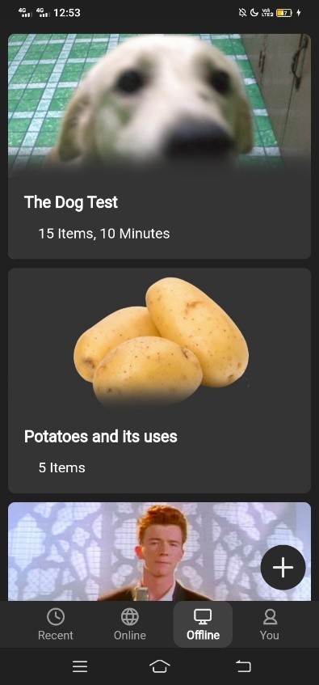

First Stable Prototype


Development of the Application

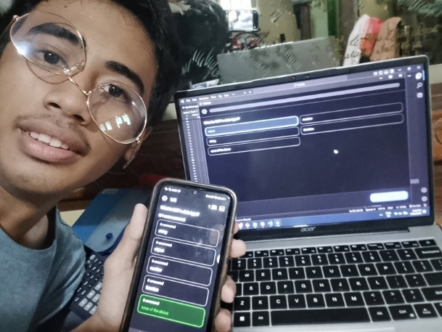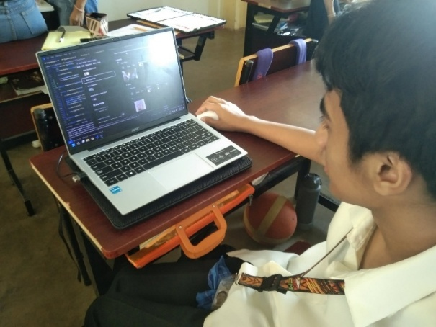

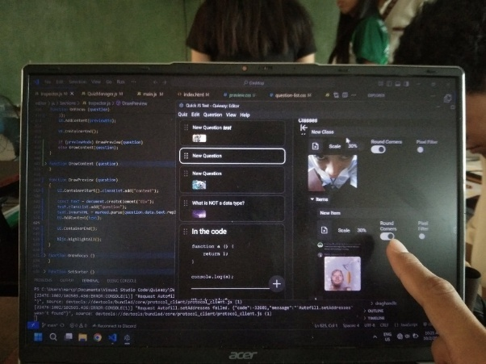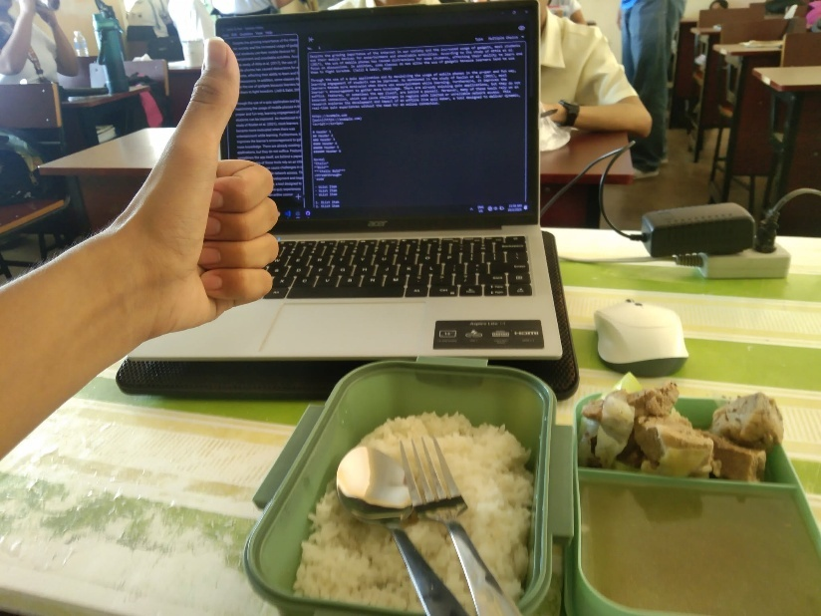

Repository Commits within the Development of the Application

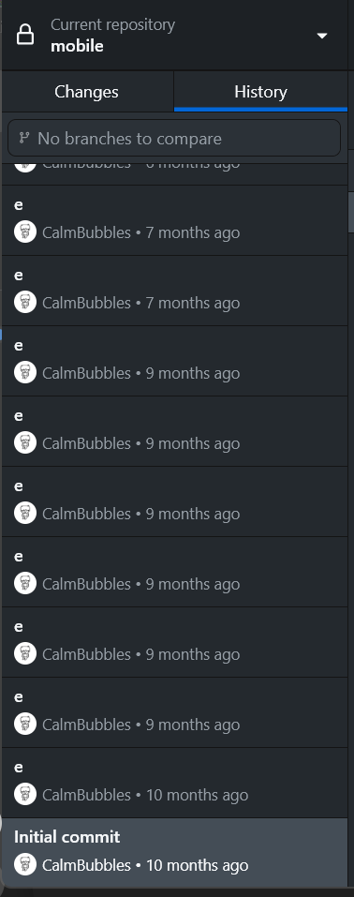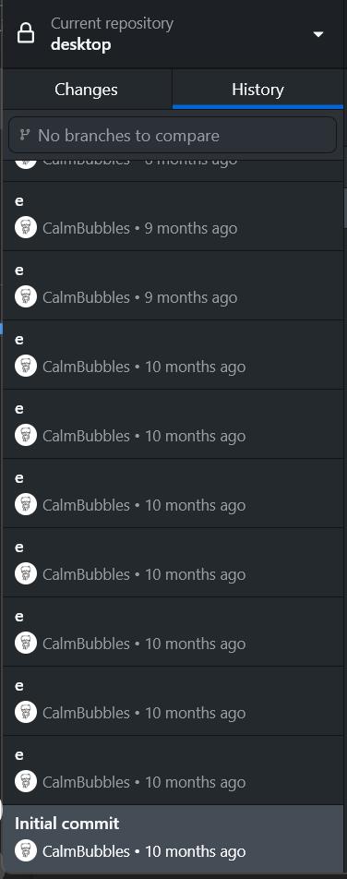

Final Output

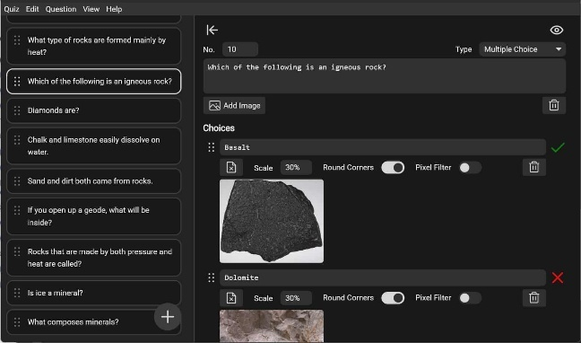

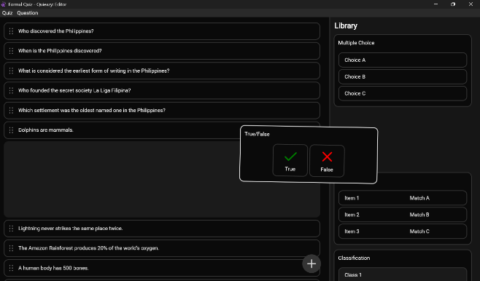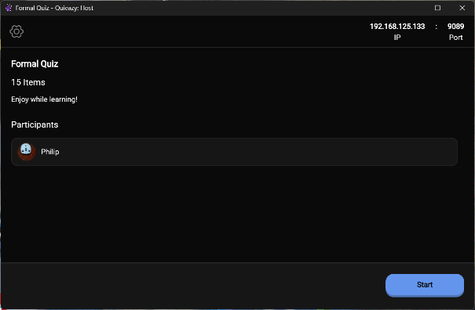

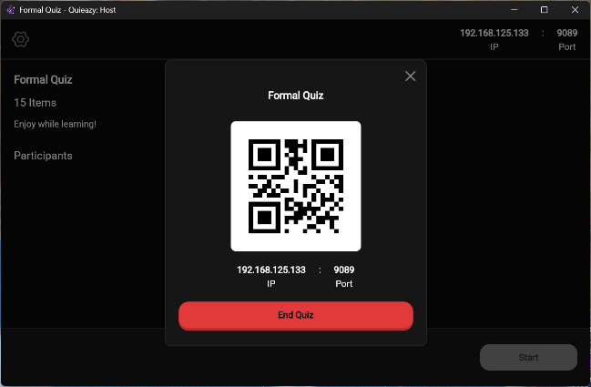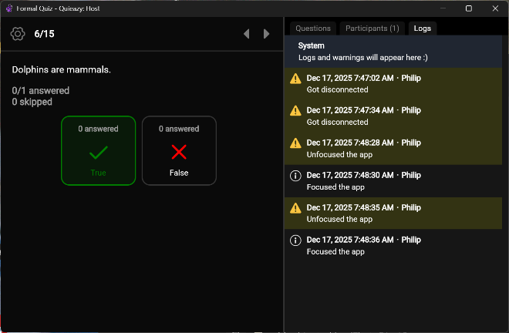
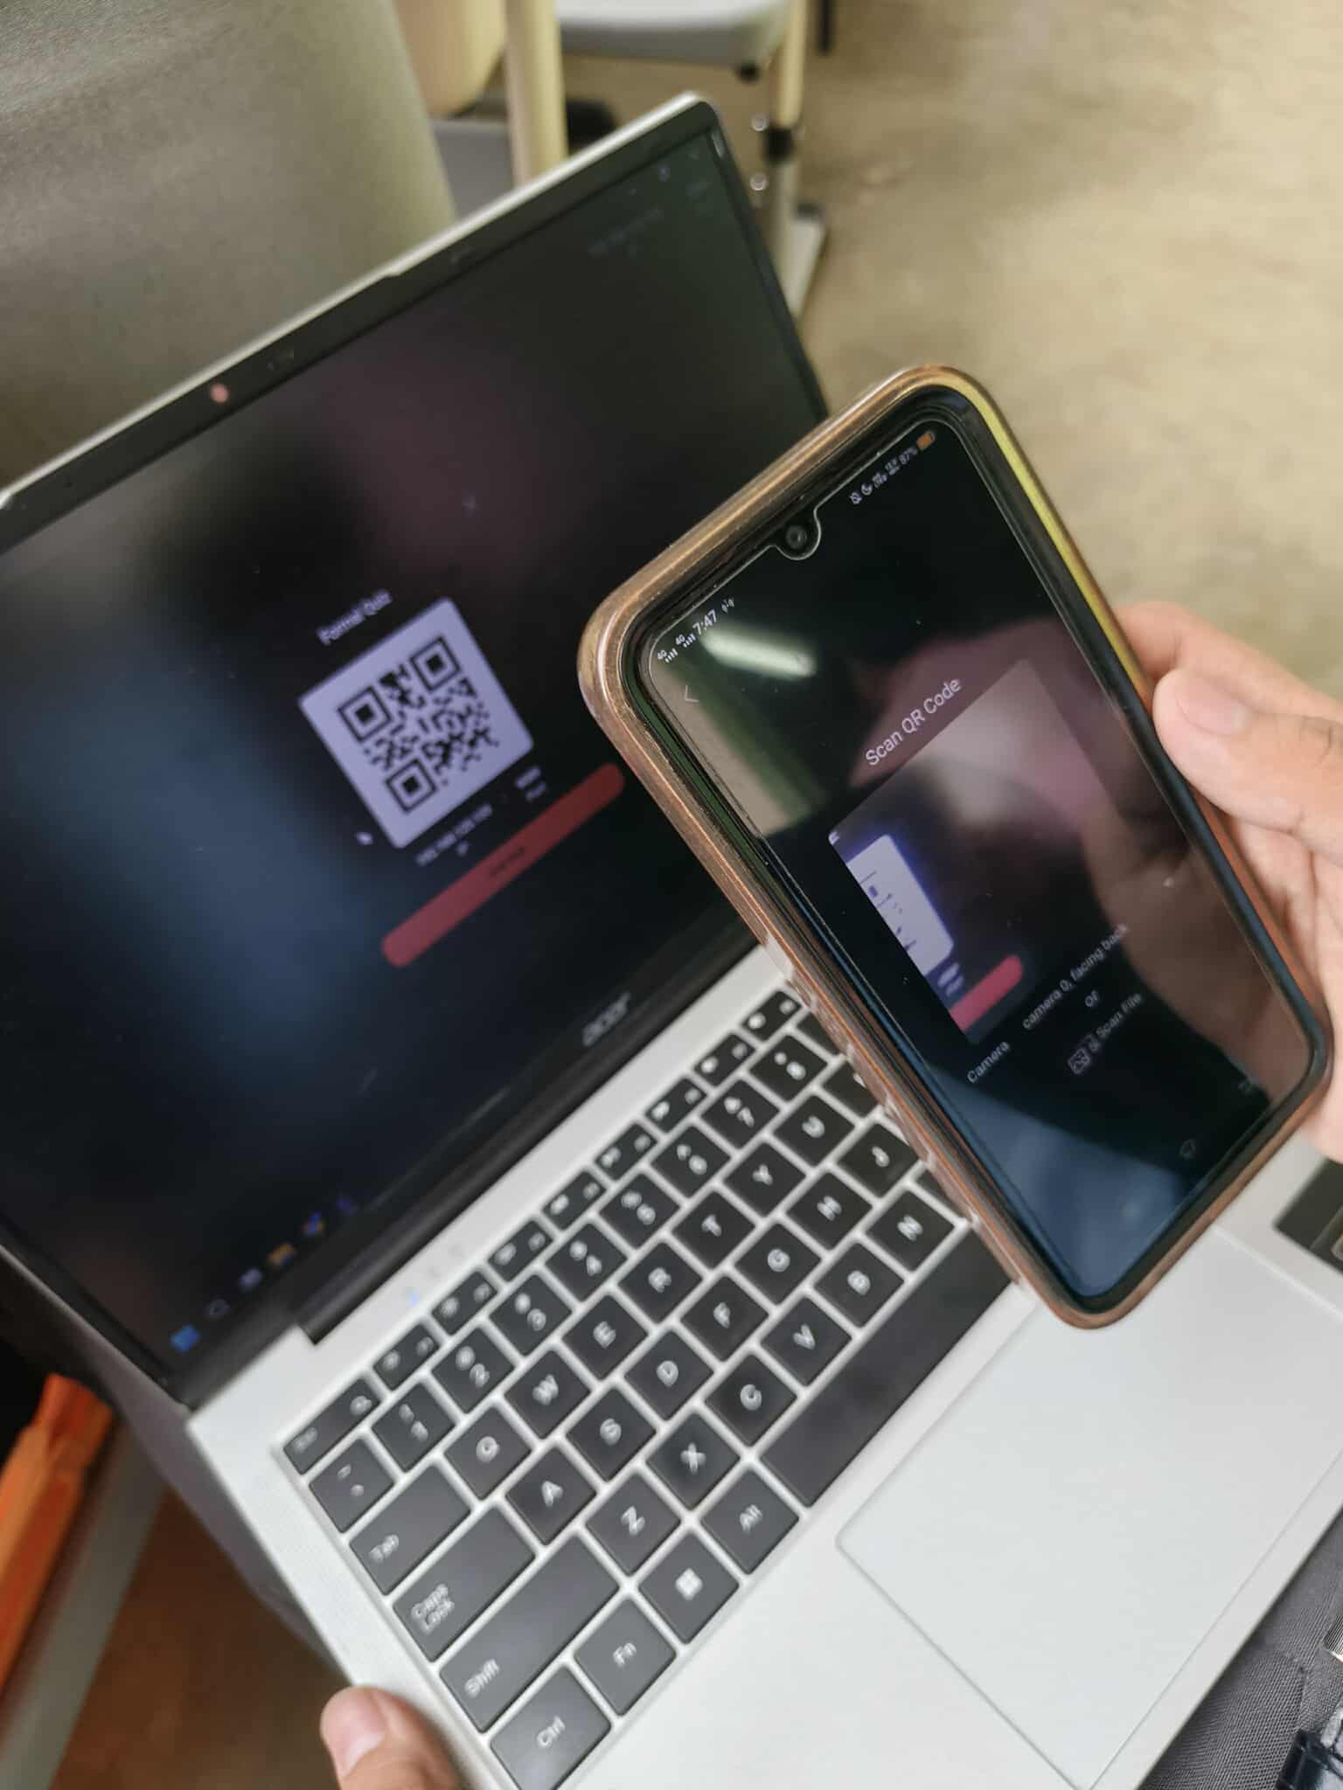

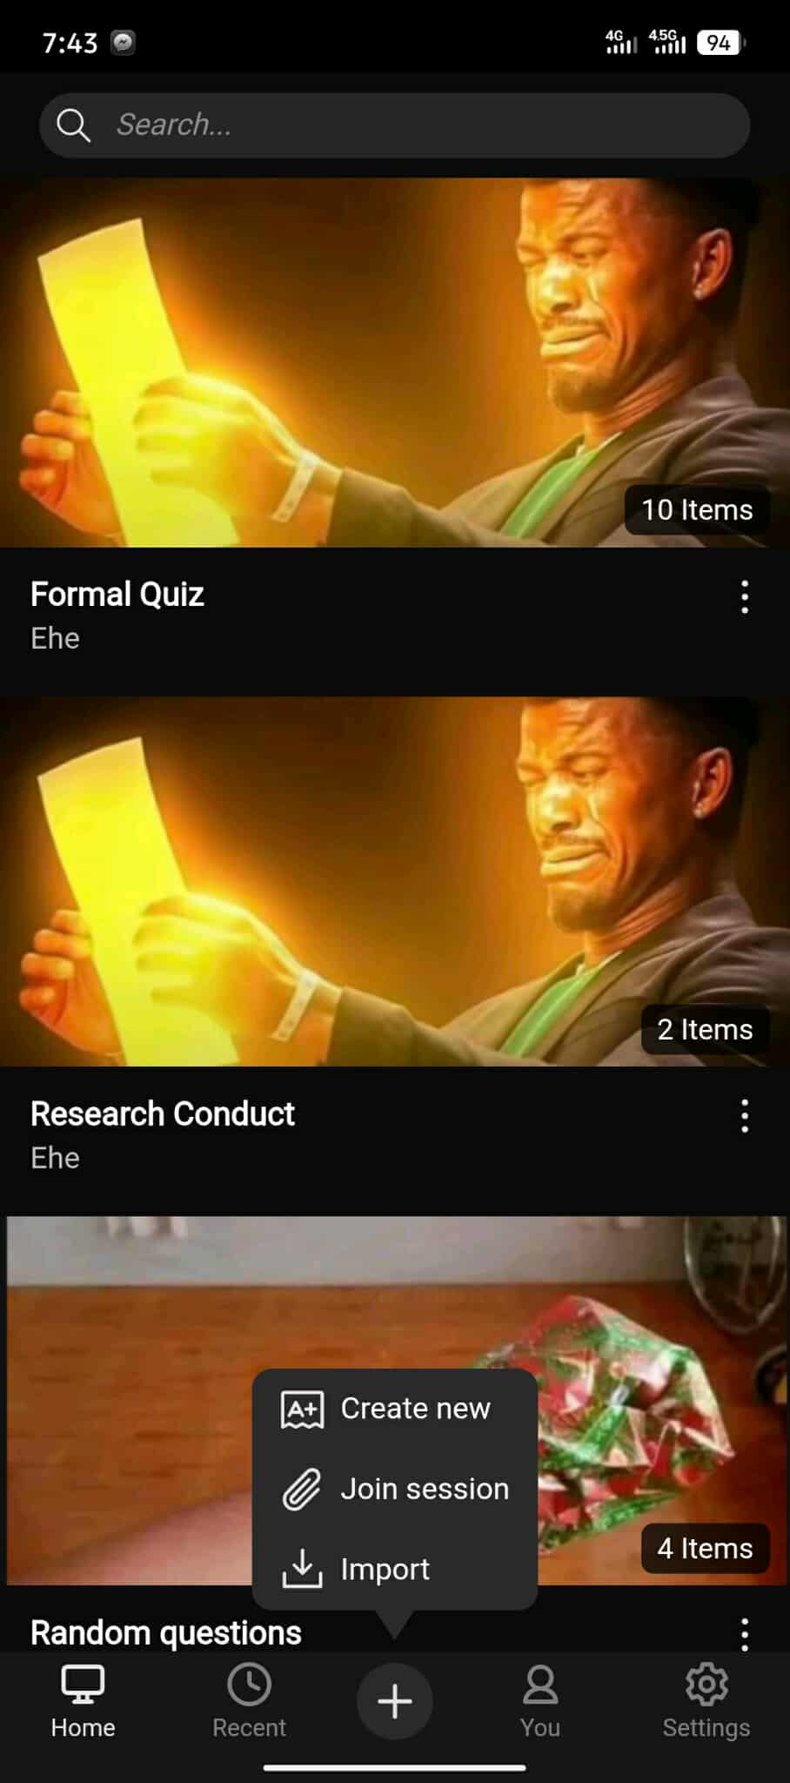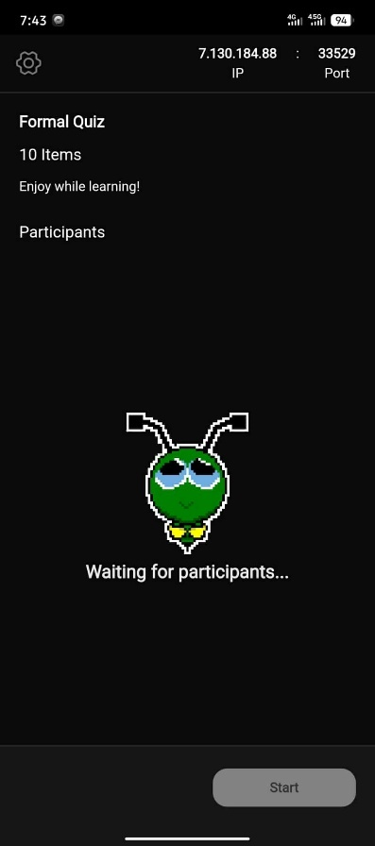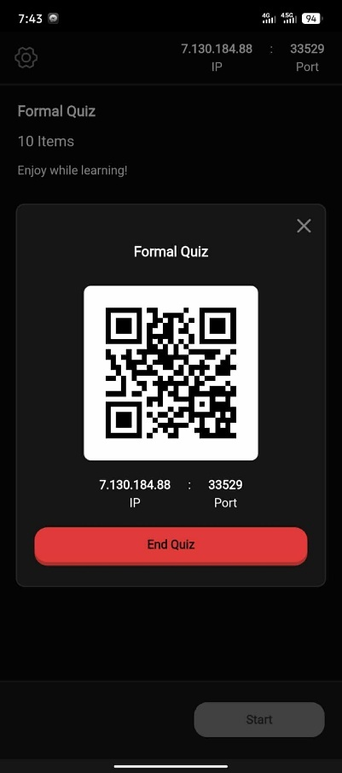
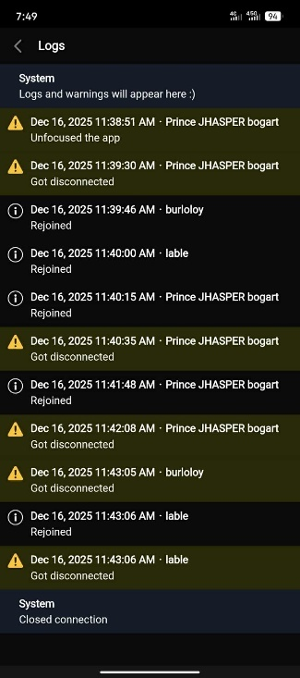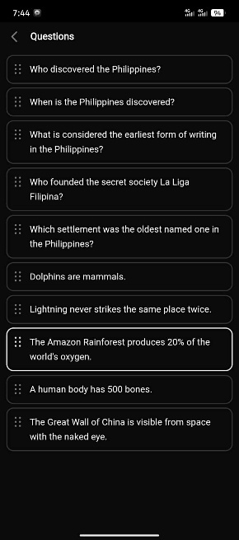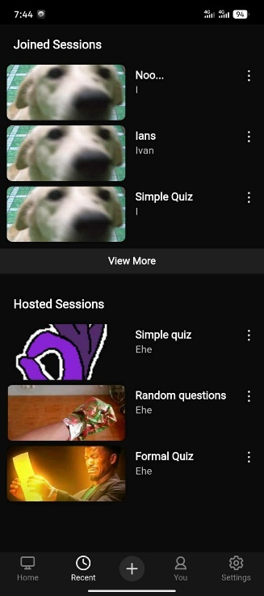

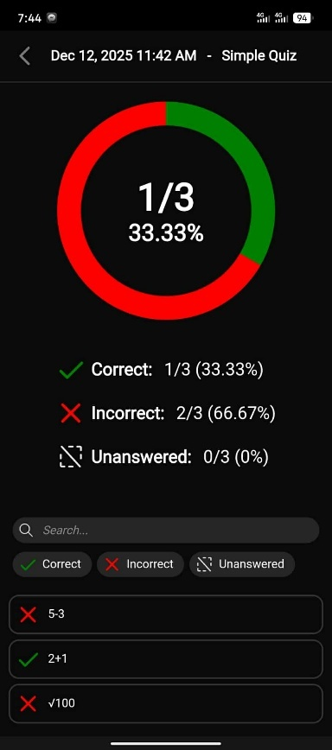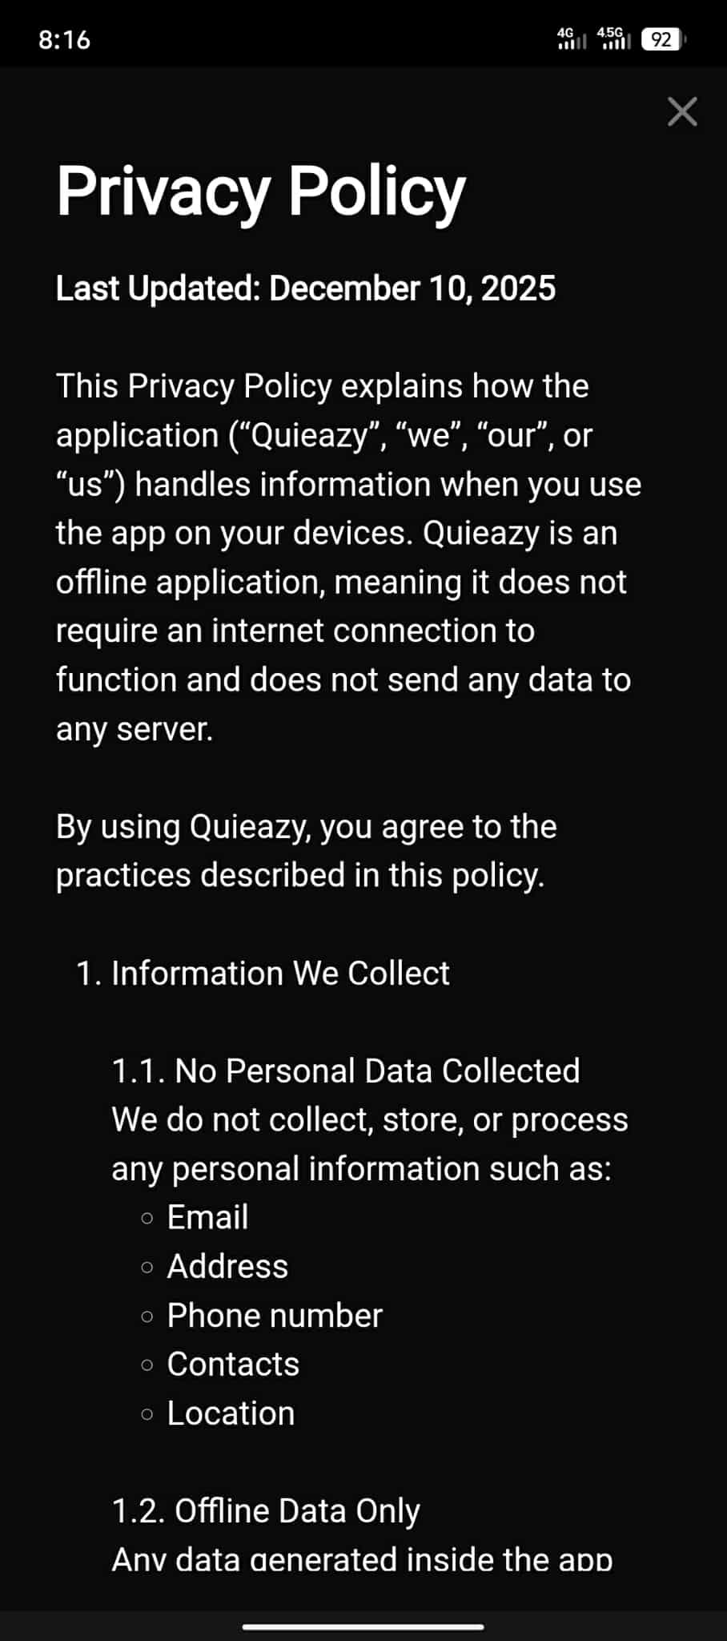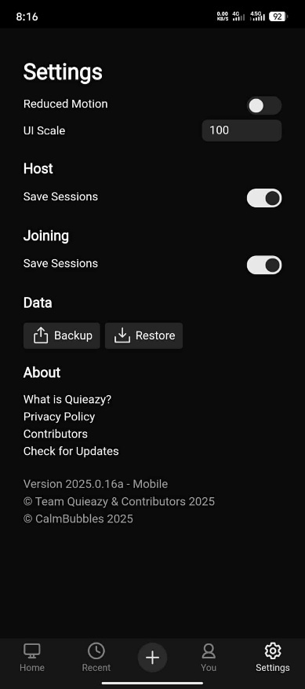

APPENDIX H
BROCHURE

APPENDIX I
Final Oral Presentation

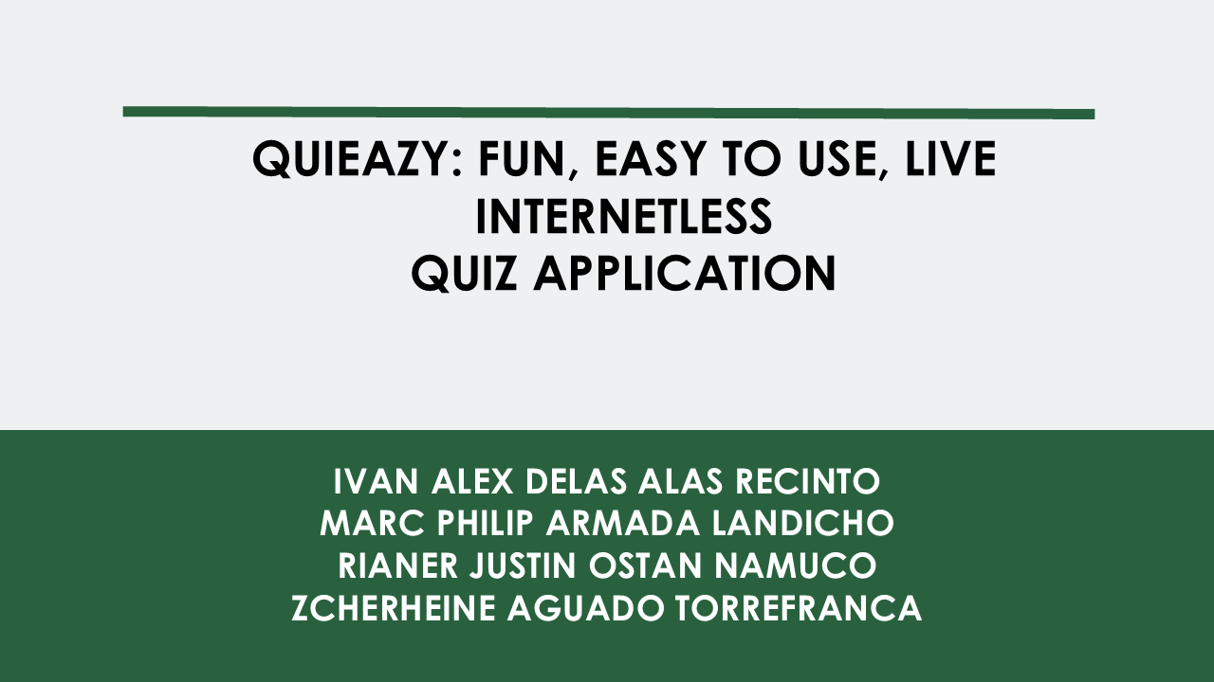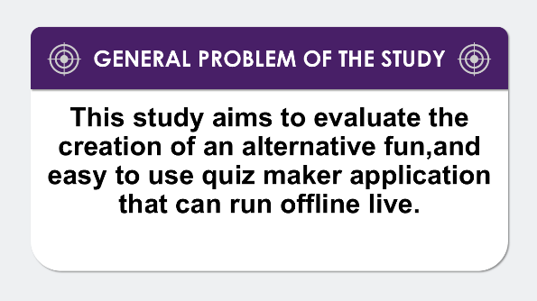

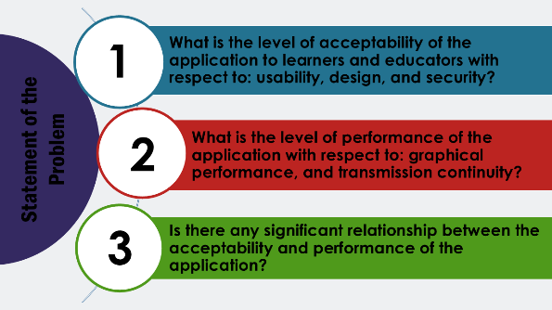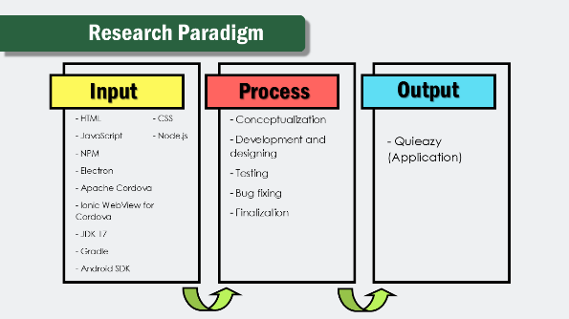

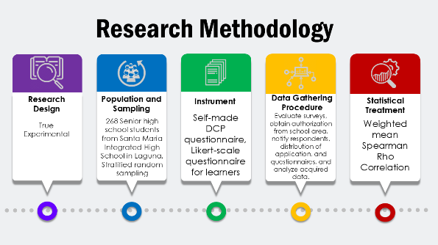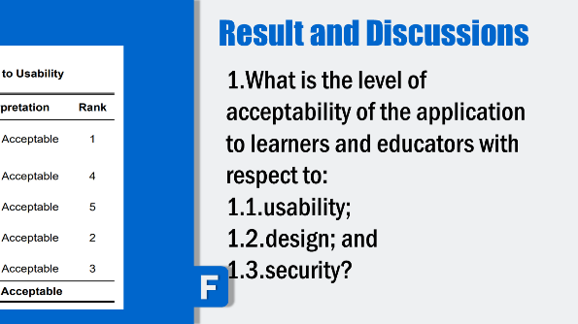

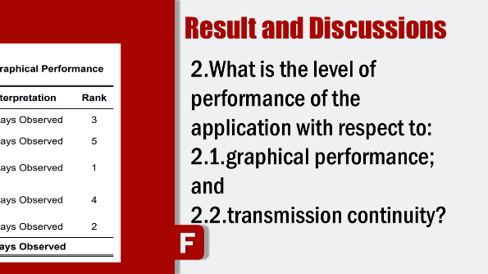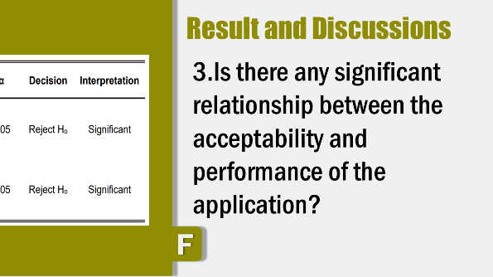

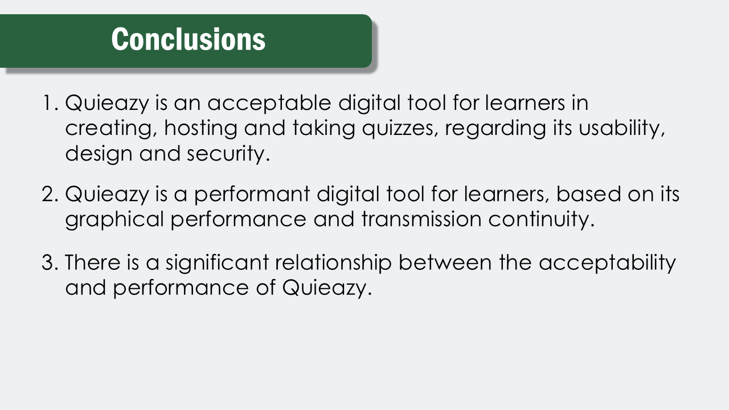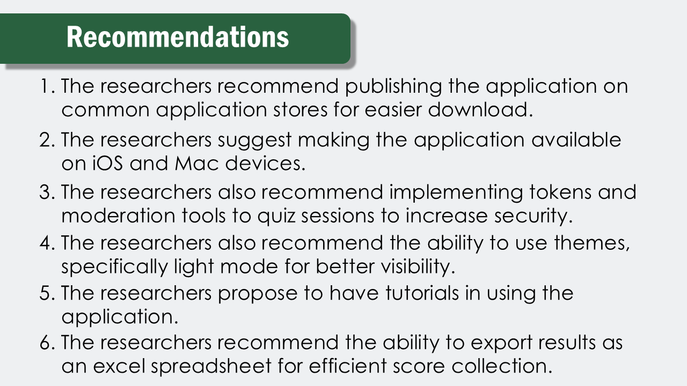

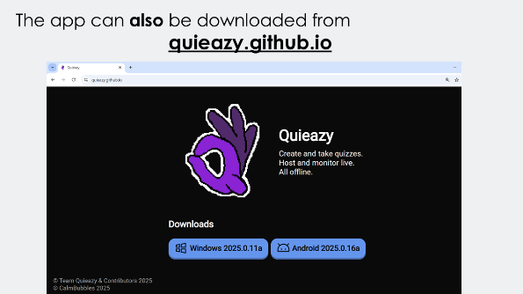

CURRICULUM VITAE


IVAN ALEX D. RECINTO
Brgy. Cambuja, Santa Maria, Laguna
Contact No.: +63 910 2439 495
Email Address: ivanalexrecinto07@gmail.com

PERSONAL DATA
Date of Birth : May 16, 2008
Place of Birth : Santa Maria, Laguna
Age : 17
Sex : Male
Nationality : Filipino
Civil Status : Single
Religion : Roman Catholic

EDUCATIONAL ATTAINMENT
Secondary Education : Sta. Maria Integrated High School
Senior High School
NUSEDELA St., Brgy. Poblacion IV,
Santa Maria, Laguna
Academic Track − STEM
(A.Y. 2024 - 2026)

: Sta. Maria Integrated High School
Junior High School
NUSEDELA St., Brgy. Poblacion IV,
Santa Maria, Laguna
(A.Y. 2020 - 2024)

Primary Education : Paang Bundok Elementary School
Brgy. Cambuja,
Santa Maria, Laguna
(A.Y. 2014 - 2020)

HONORS AND AWARDS RECEIVED
A. Y. 2020 - 2021
- Achiever
A. Y. 2021 - 2022
- Achiever
A. Y. 2022 - 2023
- With Honors
A. Y. 2023 - 2024
- Achiever
A. Y. 2024 - 2025
- With Honors
- Science Chant Making Champion


MARC PHILIP A. LANDICHO
Brgy. IV, Santa Maria, Laguna
Contact No.: ‎+63 956 0550 608
Email Address: philiparmada.landicho@gmail.com
Website: calmbubbles.github.io

PERSONAL DATA
Date of Birth : May 6, 2008
Place of Birth : Santa Maria, Laguna
Age : 17
Sex : Male
Nationality : Filipino
Civil Status : Single
Religion : Roman Catholic

EDUCATIONAL ATTAINMENT
Secondary Education : Sta. Maria Integrated High School
Senior High School
NUSEDELA St., Brgy. Poblacion IV,
Santa Maria, Laguna
Academic Track − STEM
(A.Y. 2024 - 2026)

: Sta. Maria Integrated High School
Junior High School
NUSEDELA St., Brgy. Poblacion IV,
Santa Maria, Laguna
(A.Y. 2020 - 2024)

Primary Education : Santa Maria Elementary School
Santa Maria, Laguna
(A.Y. 2014 - 2020)

AFFILIATIONS
Infinitrix Club : Public Information Officer
(2021 - 2022)

YES-O : Public Information Officer
(2022 - 2023)

: Grade 10 Representative
(2023 - 2024)

Desert Lake : Main Developer
(2022 - Present)

HONORS AND AWARDS RECEIVED
A. Y. 2020 - 2021
- With Honors
A. Y. 2021 - 2022
- With High Honors
- Science Quiz Bee Champion
A. Y. 2022 - 2023
- With Honors
- Science Quiz Bee Champion

A. Y. 2023 - 2024
- With High Honors
- Science Quiz Bee Participant
- Historical Quiz Bee National Level Qualifier
- Best in Science
- Best in Social Science
A. Y. 2024 - 2025
- With High Honors
- PopEd Quiz Bee Participant
- DSTF Best in School Shoutout
- DSPC TV Broadcasting – Technical Director – Participant
- Science Chant Making Champion
A. Y. 2025 – 2026
- DSPC TV Broadcasting – Technical Director – 3rd Place
- ARAL Reading Program Documentary Festival 2026 –Videographer/Cinematographer and Video Editor
: Special Jury Citation Key Stage 3 Basic
: Creative Poster Distinction Award



RIANER JUSTIN O. NAMUCO
Sitio Ibaba, Brgy. Nanguma
Mabitac, Laguna
Email Address: rjrianer30@gmail.com

PERSONAL DATA
Date of Birth : January 30, 2008
Place of Birth : Mabitac, Laguna
Age : 18
Sex : Male
Nationality : Filipino
Civil Status : Single
Religion : Roman Catholic

EDUCATIONAL ATTAINMENT
Secondary Education : Sta. Maria Integrated High School
Senior High School
NUSEDELA St., Brgy. Poblacion IV,
Santa Maria, Laguna
Academic Track − STEM
(A.Y. 2024 - 2026)

: Sta. Maria Integrated High School
Junior High School
NUSEDELA St., Brgy. Poblacion IV,
Santa Maria, Laguna
(A.Y. 2020 - 2024)

Primary Education : Nanguma Elementary School,
Brgy. Nanguma,
Mabitac, Laguna
(A.Y. 2014 - 2020)

HONORS AND AWARDS RECEIVED
A. Y. 2021 - 2022
- With Honor
A. Y. 2022 - 2023
- With Honor
A. Y. 2023 - 2024
- With Honor
A. Y. 2024 - 2025
- With Honors
- Science Chant Making Champion


ZCHERHEINE A. TORRERANCA
Padre Burgos St., Brgy. II,
Santa Maria, Laguna
Email Address: zcherheinetorrefranca@gmail.com

PERSONAL DATA
Date of Birth : December 19, 2007
Place of Birth : Santa Maria, Laguna
Age : 18
Sex : Female
Nationality : Filipino
Civil Status : Single
Religion : Roman Catholic

EDUCATIONAL ATTAINMENT
Secondary Education : Sta. Maria Integrated High School
Senior High School
NUSEDELA St., Brgy. Poblacion IV,
Santa Maria, Laguna
Academic Track − STEM
(A.Y. 2024 - 2026)

: Sta. Maria Integrated High School
Junior High School
NUSEDELA St., Brgy. Poblacion IV,
Santa Maria, Laguna
(A.Y. 2020 - 2024)

Primary Education : Santa Maria Elementary School
Santa Maria, Laguna
(A.Y. 2014 - 2020)

AFFILIATIONS
YES-O : Member
(2022 - 2023)

Science Club : Secretary
(2023 - 2024)

HONORS AND AWARDS RECEIVED
A. Y. 2021 - 2022
- Achiever
A. Y. 2022 - 2023
- With Honors
A. Y. 2023 - 2024
- With Honors
- Best Club (Science Club)
A. Y. 2024 - 2025
- With Honors
- Science Chant Making Champion

